Student Mentorship Effects on Immediate College Enrollment

MIS-690 Capstone Project Thesis
Submitted to Grand Canyon University
Graduate Faculty of the Colangelo College of Business
in Partial Fulfillment of the
Requirements for the Degree of
Master of Science
Business Analytics
by
Preston Moore

Tustin, California
April 9, 2025

Approved by:

Professor Date
Abstract
Mentorship provides a special lasting impact on students, leading to increased immediate college enrollment. The data mining project aimed to discover the most significant contributors to mentorship within mentee/mentor pairings that lead to the long-term outcome of immediate college enrollment the fall semester after high school graduation, with a narrowed focus on demographics and social-emotional learning. The methodology employed the CRISP-DM process for understanding and implementing key insights. Data integration in R used 4 tables, including variables such as race/ethnicity, cohorts of students, high school attended, and gender along with data including social-emotional learning (SEL) outcomes from mentee/mentor pairs collected using Qualtrics Survey data, with 2320 mentees analyzed of a population of 3,284 mentees. Exploratory Data analysis yielded several insights into different enrollment rates between genders, cohorts of students, and those who had higher pair completion in senior year of their mentorship curriculum. Using Python, the Logistic Regression, XGBoost, SVM, and KNN Machine Learning models were trained and evaluated, deploying optimal findings within a Tableau Dashboard and Gradio app for stakeholder decision-making support. Research into specific high schools, increases in pair meetings, male students, an emphasis on the SEL Outcome “planning for the job I want” and three other correlated SEL outcomes were all areas of opportunity to significantly increase the rate of immediate college enrollment as the long-term outcome. Future research will include integration of the findings and continuous monitoring, along with research into communication methods and frequency between mentor/mentee pairs.
Keywords: mentorship, college, enrollment, social-emotional learning, students
Table of Contents
List of Tables 3
List of Figures 5
Student Mentorship Outcomes on Immediate College Enrollment Rate 9
Business Problem Identification 9
Background 9
Business Problem Statement 12
Analytics Assumptions 12
Analytics Problem Statement 15
Data Understanding, Acquisition, and Preprocessing 15
Collection of Initial Data 16
Description of Data 16
Exploration of Data 19
Verify Data Quality 38
Hypothesis Statements 38
Data Diagnostics and Descriptive Summary 38
Exploratory Data Analysis 43
Trends Analysis 46
Methodology Approach and Model Building 63
Modeling Methods 63
Test Design and Model Building 66
Model Assessment & Intended Plan for Training, Testing, and Evaluation 66
Conclusion 68
Model Evaluation 68
Assess Results With Respect to Business Success Criteria 76
Conclusion 80
External Model Verification and Calibration 81
Literature Review 81
Calibration 82
Future Recommendations 92
Model Deployment and Model Life Cycle 94
Improvement Plan 94
Deployment Strategy 95
Milestones, Training, Cost/Benefit, and Risks 95
Recommendations and Conclusions 98
References 99
Appendix 104

List of Tables
Table 1 Demographics and Participation 15
Table 2 Social-Emotional Learning Outcomes 15
Table 3 Mentor Survey Data 16
Table 4 Demographics and Participation 17
Table 5 Bivariate Analysis of sem1_enr 43
Table 6 Trend analysis of sem1_enr = 0 48
Table 7 Trend Analysis of sem1_enr = 1 48
Table 8 Snippet of Initial VIF Scores 62
Table 9 Snippet of VIF Scores with Removed Multicollinearity 64
Table 10 XGBoost Initial Classification Metrics and Confusion Matrix 65
Table 11 Logistic Regression Results with Only Significant p-values 69

List of Figures
Figure 1 Cohort Year 19
Figure 2 Member Region 20
Figure 3 School Location 20
Figure 4 Student Gender 21
Figure 5 Student Race/Ethnicity 22
Figure 6 LOM Control Matches 22
Figure 7 Mentor Matches 23
Figure 8 Pair Completion Senior Year 24
Figure 9 Pair Meetings Senior Year 24
Figure 10 Semester 1 Enrollment 25
Figure 11 SEL GM Outcome 1 25
Figure 12 SEL GM Outcome 2 26
Figure 13 SEL GM Outcome 3 26
Figure 14 SEL GM Outcome 4 27
Figure 15 SEL GM Outcome 5 27
Figure 16 SEL GM Outcome 6 28
Figure 17 SEL GM Outcome 7 28
Figure 18 SEL GM Outcome 8 29
Figure 19 SEL GM Outcome 9 29
Figure 20 SEL GM Outcome 10 30
Figure 21 SEL RS Outcome 1 30
Figure 22 SEL RS Outcome 2 31
Figure 23 SEL RS Outcome 3 31
Figure 24 SEL RS Outcome 4 32
Figure 25 SEL RS Outcome 5 33
Figure 26 SEL RDM Outcome 1 33
Figure 27 SEL RDM Outcome 2 34
Figure 28 SEL RS Outcome 3 34
Figure 29 SEL RDM Outcome 4 35
Figure 30 SEL RDM Outcome 5 35
Figure 31 Semester 1 Enrollment by Cohort 44
Figure 32 ANOVA on Sem1_enr by Cohort 45
Figure 33 T-Test of Gender on Sem1_enr 46
Figure 34 Pair Completion Senior Year Trend Analysis 47
Figure 35 Pair Meetings Senior Year Filter on sem1_enr and Online Pair Completion 49
Figure 36 ANOVA for pair_mtgs_sr_yr and sem1_enr 50
Figure 37 Semester 1 Enrollments 50
Figure 38 Fall Semester Enrollment in College by Gender 51
Figure 39 Race/Ethnicity Effect on Sem1_enr 52
Figure 40 Semester 1 Enrollment by Mentor/Mentee Six Month Matches 53
Figure 41 ANOVA for matched_sixmonths 54
Figure 42 LOM Control Matches 55
Figure 43 sem1_enr by School and Gender 56
Figure 44 SEL Trends Analysis by Sem1_enr Average Rat 57
Figure 45 Tableau Dashboard 59
Figure 46 Logistic Regression Model Confusion Matrix 1 66
Figure 47 Confusion Matrix for k-fold cross-validation Elastic Nets Regularization 68
Figure 48 ROC Curve for k-fold cross-validation Elastic Nets Regularization 69
Figure 49 Evaluation Metrics for Logistic Regression Tuned Model 70
Figure 50 Classification Report and Confusion Matrix for XGBoost RF Classifier 71
Figure 51 Finding the Best k for KNN 71
Figure 52 Confusion Matrix and Evaluation Metrics for Tuned KNN Model 73
Figure 53 Distribution of Rydell High School Sem1_enr 73
Figure 54 Python code for simulation of Rydell High School 76
Figure 55 Cohorts 2020 and 2021 76
Figure 56 Python Monte Carlo Simulation: 0% to 100% online_pair_completion_sr_yr 77
Figure 57 Non-calibrated XGBoost RF Classifier Over-Forecasing Probability 78
Figure 58 Calibrated XGBoost RF Classifier with Isotonic Calibration 82
Figure 59 Confusion Matrix & Classification: XGBRF Calibrated Model on Test Data 82
Figure 60 Isotonic Calibration XGBoost Random Forest Classification on All Data 83
Figure 61 Isotonic Calibration XGBoost Random Forest Classification ROC Curve 84
Figure 62 Confusion Matrix: All Data XGBoost RF Classifier with Isotonic Calibration 85
Figure 63 College Attendance Dataset 85
Figure 64 Data Distributions of all College Dataset Variables and Descriptive Statistics 86
Figure 65 Compact Data Distribution of Variables 87
Figure 66 Classification Report on College Dataset 88
Figure 67 ROC Curve for College Enrollment Dataset 89
Figure 68 Confusion Matrix for College Enrollment Dataset 90

Student Mentorship Outcomes on Immediate College Enrollment Rate
Student enrollment rates for “immediate college enrollment rate” following high school graduation in the United States sits at 62% on average in the year 2023 (National Center for Education Statistics, 2024). To address this issue, adequate solutions such as mentorship provide specialized pathways for students to obtain immediate college enrollment. Non-profit companies seek to represent under-privileged groups through mentorship in order to provide long-term impacts in college and career success, ultimately leading to increased representation, success, and economic growth for first-generation college students, uplifting and ultimately building the communities one high school at a time, according to iMentor (2025), rather than allowing the status quo to remain.

Business Problem Identification: Background
The mentorship company began in 1999 as a way to address a specific need for a high school in South Bronx, New York for increased mentorship leading to increased college enrollment (iMentor, 2025). There are now 10,000 students across 51 high schools served by 116 program sponsors across 4 different areas. Mentorship for areas of social-emotional learning outcomes, demographics, and program-specifics for each cohort are explored to discover contributions to further increase immediate college enrollment.

Problem Identification
College readiness includes rigorous academic proficiency in math and literacy, contrasting with career readiness defined as academics applied in the workplace, technical aptitude, and the skills useful in a job such as critical thinking and problem solving (Xing et al., 2019). These benchmarks blend together to create a data-informed knowledge base on how benchmarks are crafted to inform a student’s college readiness.According to the National Center for Education Statistics (2024), in 2022 lower rates of males enrolled immediately into college than females (57% and 66% respectively). In 2017, according to the U.S. Department of Education, 10.84% of high school graduates did not enter the workforce nor went to college (Xing et al., 2019). This problem underscores the need for applications of mentorship, in addition to academic and career readiness initiatives to ensure increased preparation to enter into college or the work force.
Previous Problems
The current status of mentorship is a compartmentalized application within only small groups of students, but is not applied to the United States as a whole. This means that only certain schools, cities, states, and groups of students are affected positively by these mentorship initiatives. According to Xing et al. (2019), only small swaths of state and federally funded programs reach students who participate in college and career preparation activities. Additionally, disruptions such as the COVID-19 pandemic (2020-2023) have created challenges of GPA inflation, lower overall ACT scores, loss of standardized testing, and an increasingly complex identification method for immediate college enrollment (Knox, 2024). Additionally, Knox explains how some high education institutions' application processes rely on GPA or test scores, along with classwork as indicators, rather than on additional factors including analytics solutions.
Influencing Factors
Some potential factors that are influenced by the problem include finding an internal sponsor (IBM, 2018), availability of meetings for each student/mentee, financial constraints - mentee/mentor pairs being able to receive the resources, continued partnership with the company or how many additional partners can be found. Without these external sponsors, and showing proof through data visualization and analytics solutions that the mentorship programs are profitable, donors and sponsor partners will decrease funding for the mentorship program. Overall socio-economic status was the largest deciding factor in the research study (Xing et al., 2019). However, one conclusion that supports the influencing factors in this project that does not explore just socio-economic factors, but also additional variables, is that “exposure to further education and career options will push students to start to think about educational and career choices to make in the immediate future and manage to develop the knowledge and skills to become college- and career-ready” (Xing et al., 2019).
Stakeholders
The main body of stakeholders that can be interviewed to understand the root cause of the issue include: identified Mentors, Data Collection Experts designing the Qualtrics Survey Data, the individuals responsible for maintaining the pair completion methodology, and the software development team utilized to create the LOM Control Matches. Additionally, stakeholders include parents or families of mentee students and the entire business as a whole, all invested in the mission to help these mentee students obtain on-time semester college enrollment. Stakeholders include donors and program partners, at various levels of donations.
Data, Tools, and Techniques
Data collection challenges must align with departments who structure the data warehouses and define data dictionaries, schemas, and ERDs to be obtained (Pigato, 2014). This means that the necessary data for this project must be obtained through consulting Microsoft Excel server data warehousing and in conjunction with data teams. The dataset for this research project is static. However, the necessary data in some instances such as all mentor/mentee communications may not be available, leading to less variables contributing feature importance. The tools utilized will encompass Microsoft Excel, Tableau, R, and Python. A multinomial binary classification model will be explored, comparing Logistic Regression, XGBoost, KNN, and Support Vector Machines. The overall CRISP-DM process will be followed, iteratively building on data cleaning, exploration, modeling, deployment, along with sticking to business requirements each step of the way.
Benefits
The benefits to conducting a data mining project focused on understanding the influence of utilizing mentorship to influence immediate college enrollment are:
- an increased visibility and emphasis on specific resources to increase mentee program completion, college enrollment, increased SEL scores, and better mentorship partnerships with local school districts and donor partners.
- Larger support for more student populations for first-generation college pathways for students, leading to more program sponsors and increased funding.
- Research insights to support further specific mentorship programs across the United States.
- Heiser & Farah (2006) explain that a problem-solving process must include a hypothesized reason and then solution to then test, similarly to the scientific method. For this reason, the hypothesized benefit would be an increase in student immediate college enrollment rates for first-time generation college students.
- Competitive benchmarking with clear benchmarks for future mentorship programs.

Business Problem Statement
Male and Female high school graduate immediate college enrollment rates across the United States are low, and mentorship programs are sporadically yet widely distributed to address core issues leading to low enrollment rates. Mentorship programs that focus on specific long-term outcomes along with demographics data leads to meaningful change to improve immediate college enrollment while sustaining business practices for the long-term.

Analytics Assumptions
According to Gouvea (2021), assumptions that are implicit should be made explicit, along with clarifying data quality, external factors, estimates, and the way the information is presented. All data in this study is anonymized to prevent leakage of Personally Identifiable Information (PII).. Data quality issues include missing data (to be resolved with value imputation or removal), data integration, data aggregation issues (overall communication trends vs. daily communications), and a lack of multiple years worth of data. For example, even though access to this static dataset is available, continued access to the previous years (1999-2018) is not available, along with communication trends only being compiled for 382 (10%) of the overall mentee/mentor pairs. External factors such as the COVID-19 Pandemic, the rise of Social Media, affirmative action initiatives, and poor data reporting can all have confounding effects on the collected dataset.
Inputs will include Social-Emotional-Learning (SEL) outcomes collected from mentor survey data, race/ethnicity, mentorship program demographics, high school, cohort, location of the program, and mentor/mentee communications. These inputs will be considered features toward a binary classification label called “sem1_enr” representing immediate college enrollment the fall semester following high school graduation. There are three big components in a data mining project: similarity measures, predictive performance assessment, and dimension reduction (Jaggia et al., 2023). In this project I will utilize feature engineering, dimension reduction through regularization or PCA, and measures of model performance such as Correlation Tables, R2, MAE, RMSE, MSE, Chi-Square, regression coefficients, Confusion Matrices, ROC Curves, and AUC Scores to create and compare the strongest models for prediction and prescriptive analytics. Additionally, I will be simulating the effects of changing average inputs with Monte Carlo Simulation that will lead to creating recommendations for business action.

Analytics Problem Statement
Classify students into two groups: those who will enroll immediately into college the fall semester after high school graduation and those who won’t, then creating a predictive model using logistic regression, decision tree classification models, and other relevant classification models to determine the impact of mentorship, demographic factors, and mentorship curriculum usage on the two samples of students.

Data Understanding, Acquisition, and Preprocessing
The data needs include student and mentor data, demographics, social-emotional learning (SEL) outcomes, and communication data. The data will be used to look at the contributing factors for the main key performance indicator, which is the “sem1_enr” variable, representing enrolling in college the fall semester immediately following graduation from high school. This key performance indicator is a binary variable which will be useful in future predictions on whether or not the mentoring program has significant effects, along with which variables affect most affect immediate college enrollment. There are three very important sets of variables contributing to the main KPI: SEL outcomes, Mentor Survey data (including communication methods), and Student Demographics.

Collection of Initial Data
Survey collection software, Qualtrics, collected the data for mentor survey data. After being accessed from Qualtrics, the data was transformed into four CSV files and made available via a cloud Microsoft Excel link as static files. After downloading locally, the data was loaded into R for data cleaning, integration, and wrangling, following then into Python 3.12.4 for initial data description, descriptive analysis, and data understanding. The separate tables in a star schema had significant quality issues including duplicate values, missing values, incorrect formatting, and missing survey data. Additionally, several variables representing the same variable had differing names, leading to the need for integration into one labeled variable.
The data requirements included in the 4 tables were as follows: social-emotional learning outcomes, communication between mentor-mentee pairs, student demographics including participation metrics, and a table that had a primary key connected to a foreign key in order to connect to other tables within the schema which consisted of Student ID and Pair ID.

Description of Data
The dataset includes several types of variables such as ordinal, continuous, nominal, and discrete, being of types numeric (float, integer) and categorical (such as year or member region).

Table 1
Demographics and Participation
Variable Name | Definition | Data Type
user_id | Student User ID | nominal
cohort | The high school graduation cohort | nominal
Member | Name of the Region or Partner Program | nominal
school | The high school the student attended | nominal
gender | Student gender | nominal/binary
race/ethnicity | Student race/ethnicity | nominal/categorical
LOM (control matches) | Number of days a student was matched across multiple matches | continuous/numeric
matched_sixmonths | Dichotomous variable indicating whether a student's length of match equals at least six months | discrete/numeric
# of Mentors | Number of mentor matches lasting at least ten days | discrete/numeric
online_pair_completion_sr_yr | % lessons pairs completed from senior year | continuous/numeric
pair_mtgs_sr_yr | Number of times a pair met their senior year | discrete/numeric
sem1_enr | Student enrolled in fall semester immediately after high school | discrete/binary/numeric

Table 2
Social-Emotional Learning Outcomes
Variable Name | Definition | Data Type
user_id | Student User ID | nominal
SEL.GM_1 | Finishing tasks even if they are hard for me. | discrete/numeric
SEL.GM_2 | Reaching goals that I set for myself. | discrete/numeric
SEL.GM_3 | Taking action to reach my goals. | discrete/numeric
SEL.GM_4 | Setting goals for myself. | discrete/numeric
SEL.GM_5 | Overcoming obstacles in order to reach my goals. | discrete/numeric
SEL.GM_6 | Finishing the tasks I have started. | discrete/numeric
SEL.GM_7 | Taking steps to have the future I want for myself. | discrete/numeric
SEL.GM_8 | Thinking through the steps it will take to reach my goal. | discrete/numeric
SEL.GM_9 | Planning for what job I want to do when I'm older. | discrete/numeric
SEL.GM_10 | Working on my goals in school. | discrete/numeric
SEL.RS_1 | Sharing what I am feeling with others. | discrete/numeric
SEL.RS_2 | Talking to an adult when I have problems at school. | discrete/numeric
SEL.RS_3 | Getting along with adults at school even when we disagree. | discrete/numeric
SEL.RS_4 | Making friends with people who have different opinions than me. | discrete/numeric
SEL.RS_5 | Introducing myself to a new person. | discrete/numeric
SEL.RDM_1 | Thinking about what might happen before making a decision. | discrete/numeric
SEL.RDM_2 | Asking for advice when making an important decision. | discrete/numeric
SEL.RDM_3 | Being respectful of someone else's beliefs when sharing my own. | discrete/numeric
SEL.RDM_4 | Following through with my responsibilities. | discrete/numeric
SEL.RDM_5 | Taking safe risks to do something that is important to me. | discrete/numeric

Table 3
Mentor Survey Data
Variable Name | Definition | Data Type
Pair ID | Unique ID for Mentor-Student Pair | nominal
Mentor User ID | Unique ID for Mentor | nominal
Date | Date Survey Submitted | discrete/datetime
Mentor_Comm.yn | Did you communicate to your mentee this month? (Email, text, or phone) | discrete/binary
Mentor_Comm.type | How did you talk to your mentee this month? | discrete/categorical
Mentor_Meet.yn | Did you meet with your mentee this month? | discrete/binary

Table 4
Descriptive Statistics
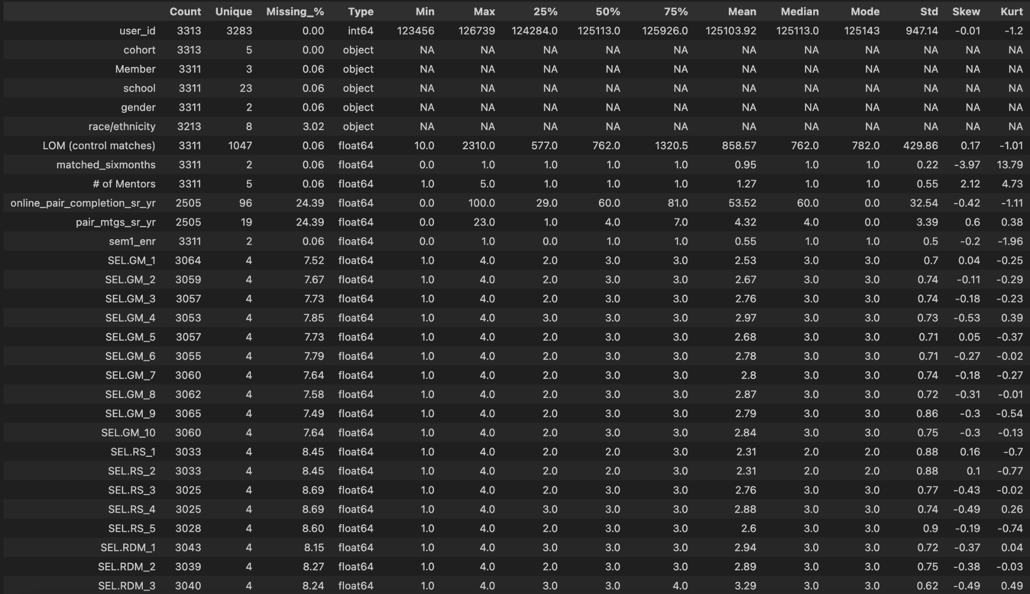
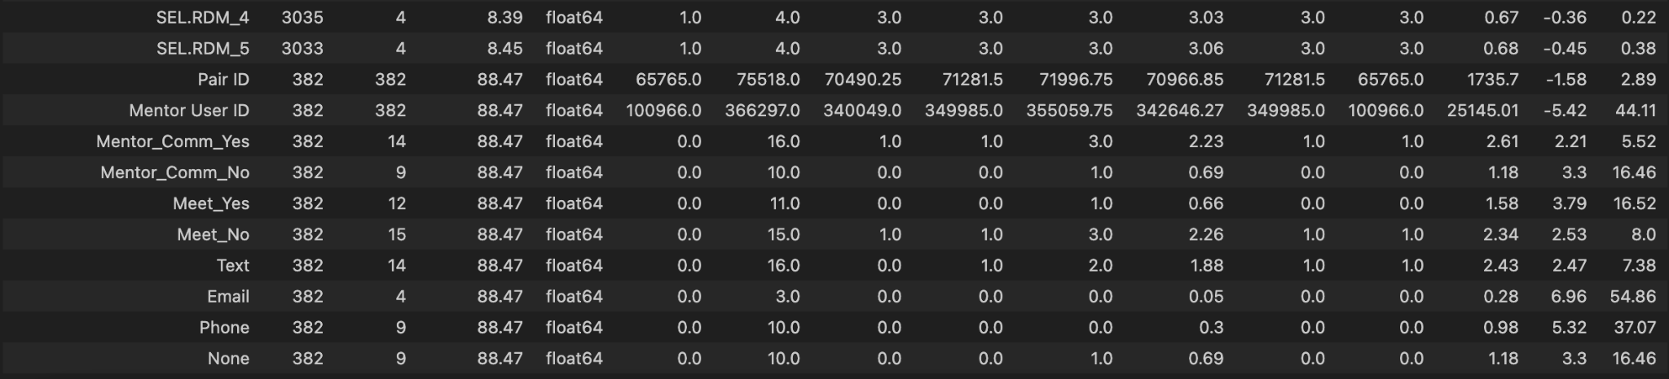

Exploration of Data
Based on the data visualizations, there are several data quality issues that will need to be addressed, such as the data types, missing data, outliers, a data integration bias. Using data visualization techniques in Tableau and Python, univariate statistics in Python, and bivariate statistics in Python, some initial observations of the data include the following:
- Pair ID and Mentor User ID need to be changed to strings rather than numeric data type. This is a data quality issue.
- The largest two cohorts were 2021 and 2022, with similar numbers of students in each cohort. This may be valuable in comparing these two specific samples within the population since the sample sizes are similar.
- iMentor NYC is the largest group of students. To prevent Simpson’s paradox, when looking at data, clustering will be utilized to prevent coming to conclusions in the data that is a cause of disaggregation.
- There are disproportionate numbers of race/ethnicity within the student population, meaning that oversampling and undersampling techniques will be required when analyzing based on race/ethnicity for creating predictive analysis, in addition to utilizing these undersampling/oversampling for immediate college enrollment.
- LOM Control Matches has a normal distribution with two peaks.
- A couple of the variables such as number of mentors and online pair completion senior year have non-normal (skewed) distributions with skewness greater than or less than +1 or -1 respectively.
- All of the Social-Emotional Learning Outcomes have normal distributions, with skewness and kurtosis contained between -1 to +1.
The following data visualizations were helpful in understanding data distributions, categorical variable sample sizes, and initial data discovery for the data mining process. Each data visualization also has a boxplot to help with meaningful outlier detection and an idea of skewness, kurtosis, normality assumptions, and if data transformations will be required, supporting initial univariate statistical analysis.

Figure 1
Cohort Year
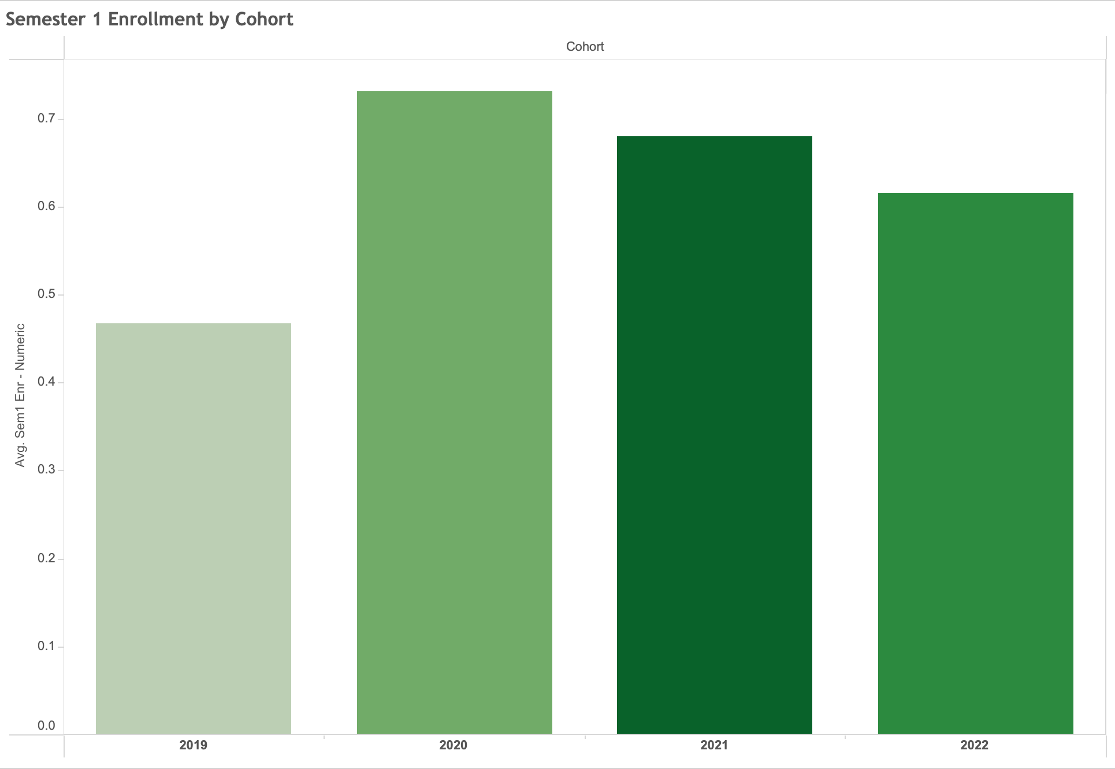
Figure 2
Member Region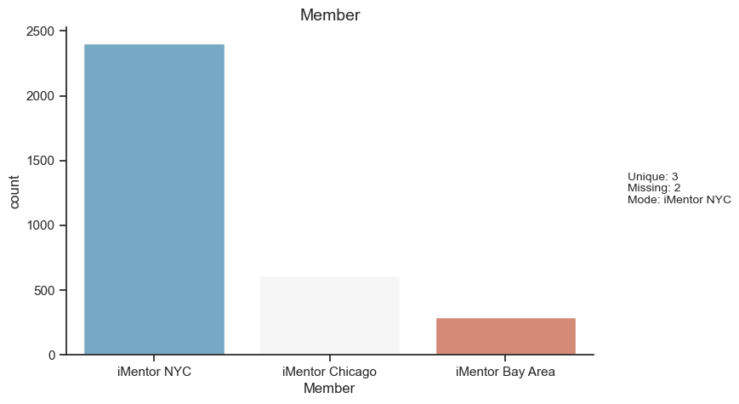

Figure 3
School Location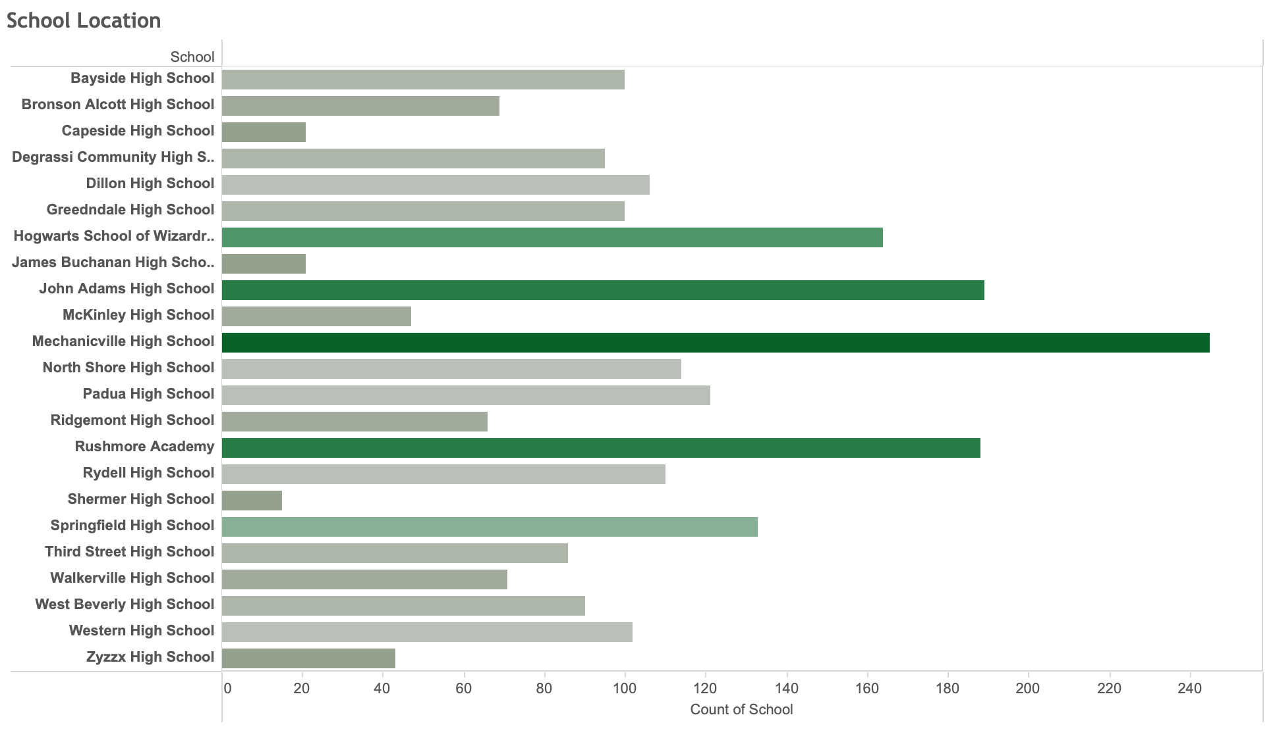

Figure 4
Student Gender
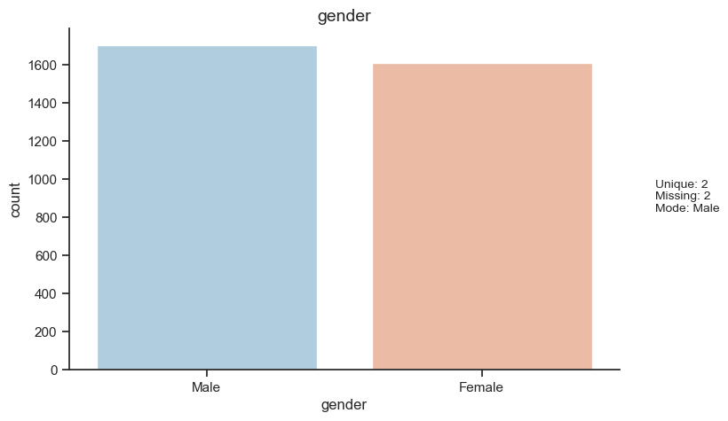

Figure 5
Student Race/Ethnicity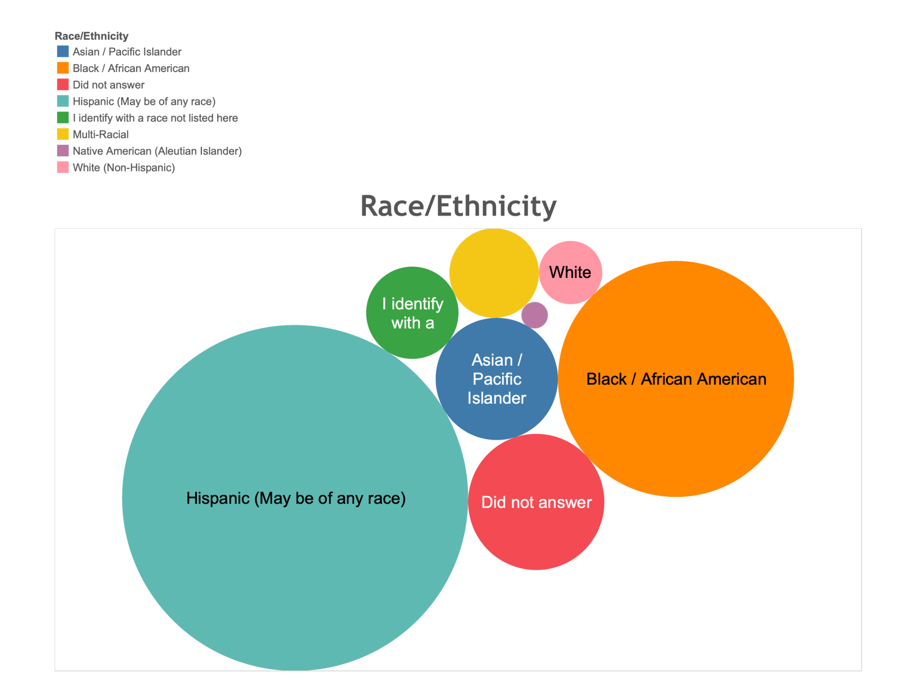

Figure 6
LOM Control Matches
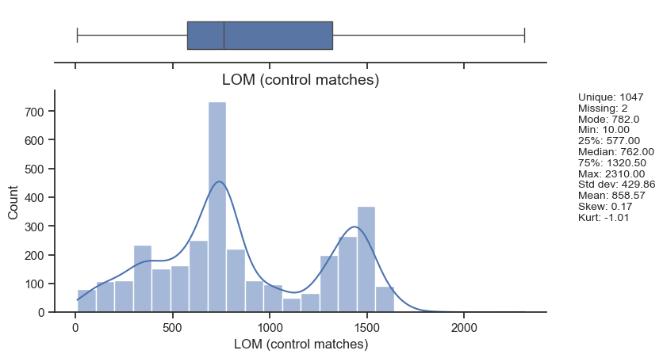
Figure 7
Mentor Matches
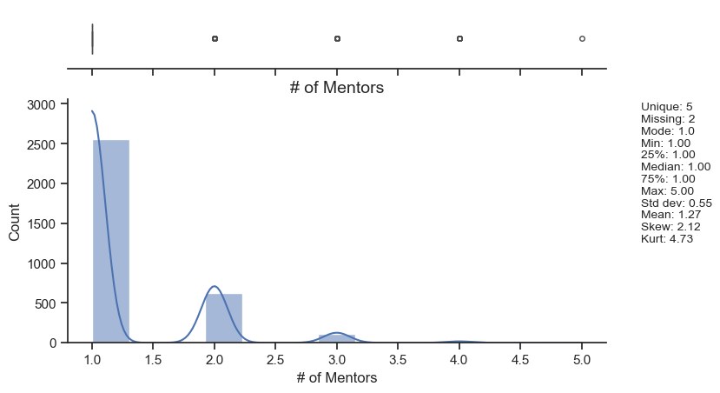

Figure 8
Pair Completion Senior Year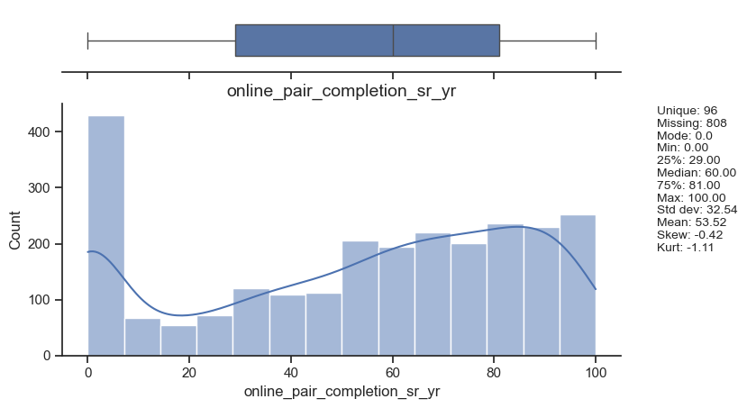

Figure 9
Pair Meetings Senior Year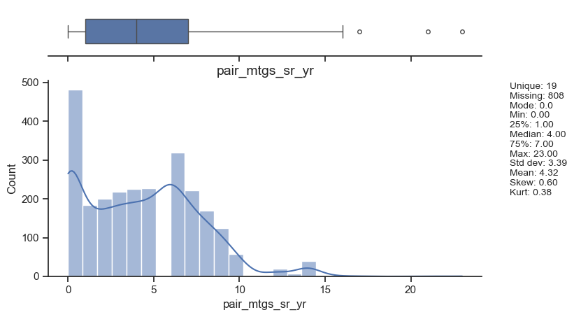

Figure 10
Semester 1 Enrollment

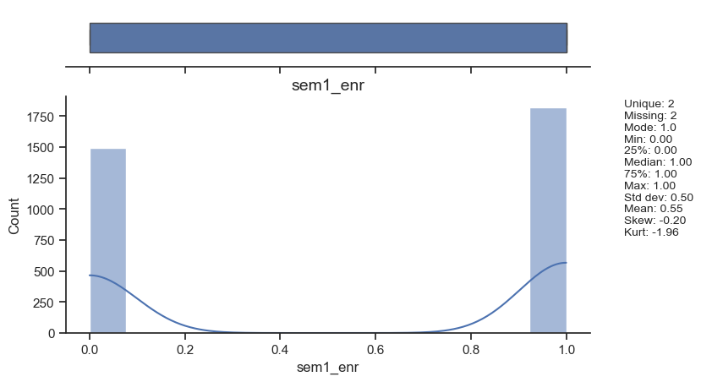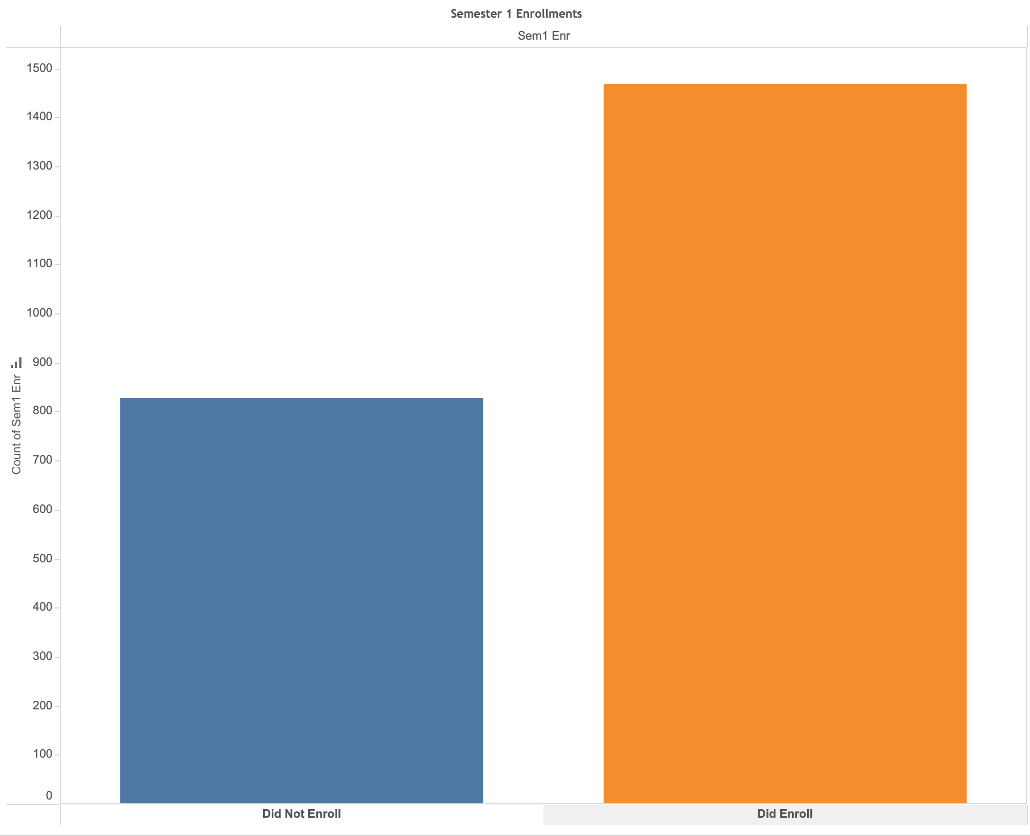

Figure 11
SEL GM Outcome 1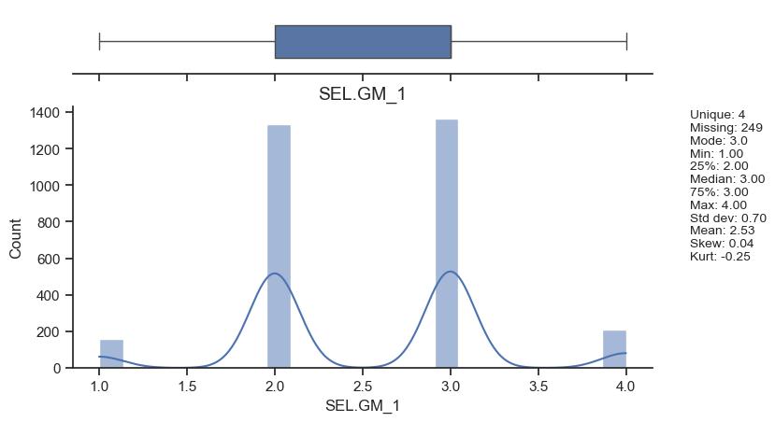

Figure 12
SEL GM Outcome 2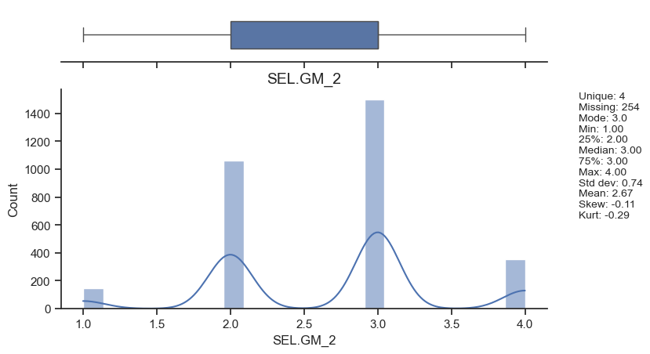

Figure 13
SEL GM Outcome 3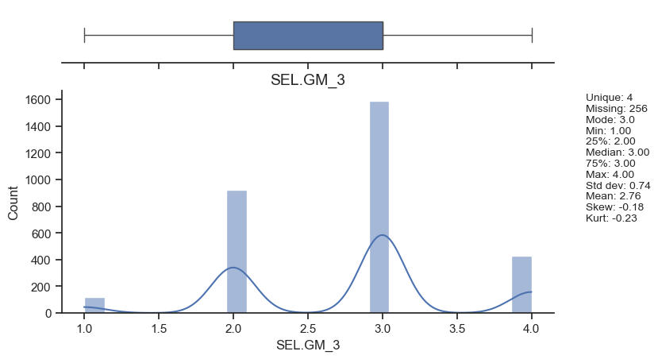

Figure 14
SEL GM Outcome 4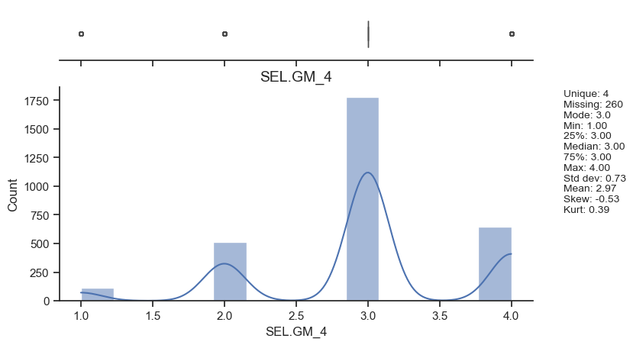

Figure 15
SEL GM Outcome 5
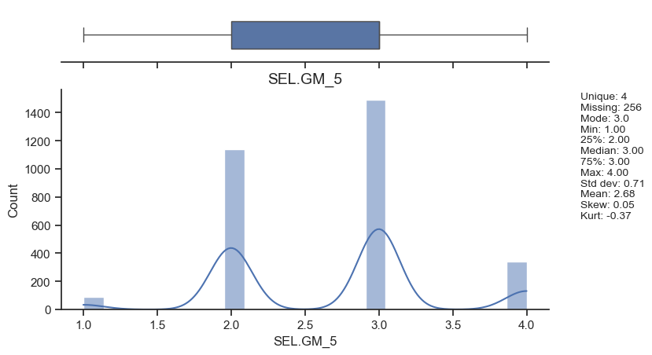Figure 16
SEL GM Outcome 6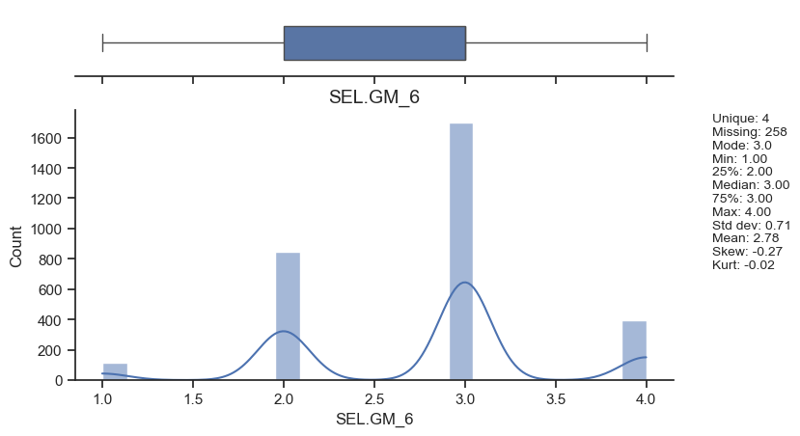

Figure 17
SEL GM Outcome 7
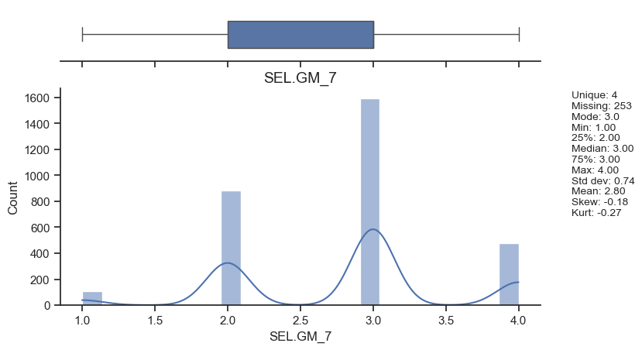
Figure 18
SEL GM Outcome 8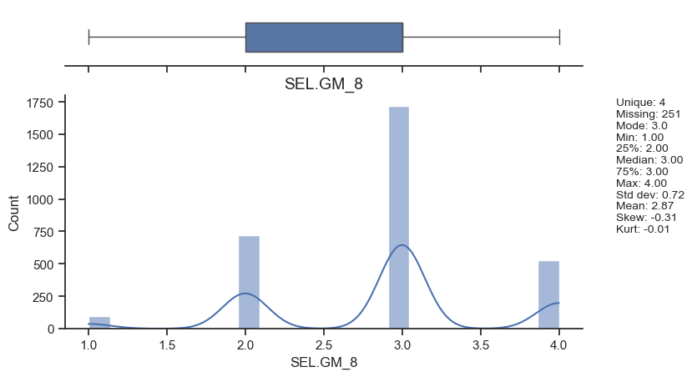

Figure 19
SEL GM Outcome 9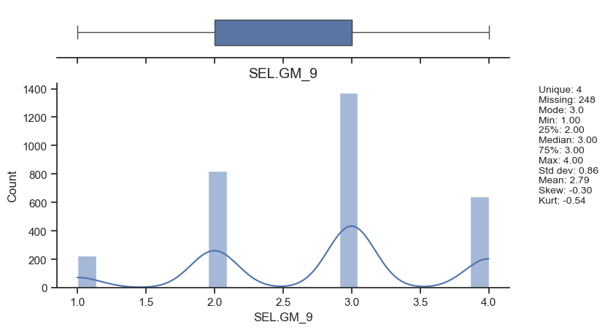

Figure 20
SEL GM Outcome 10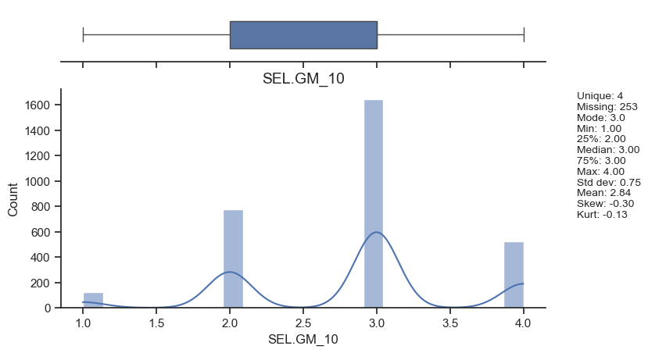

Figure 21
SEL RS Outcome 1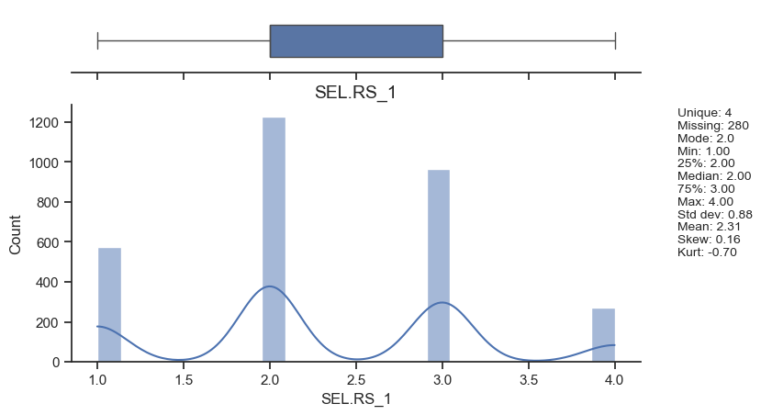

Figure 22
SEL RS Outcome 2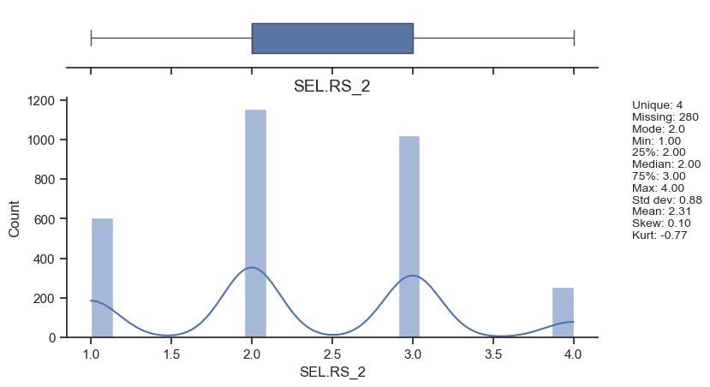

Figure 23
SEL RS Outcome 3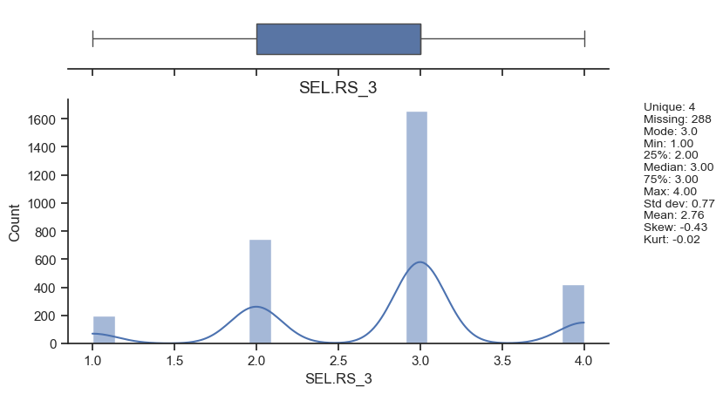

Figure 24
SEL RS Outcome 4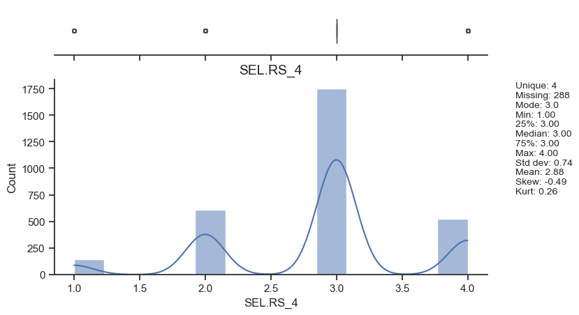

Figure 25
SEL RS Outcome 5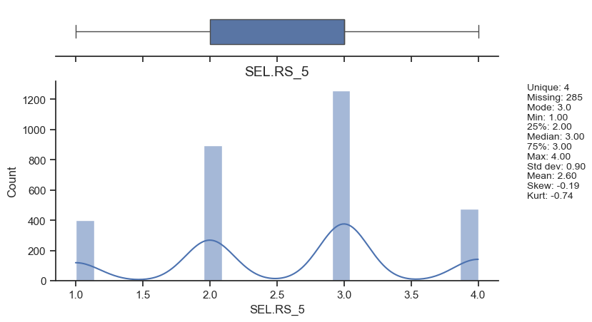

Figure 26
SEL RDM Outcome 1
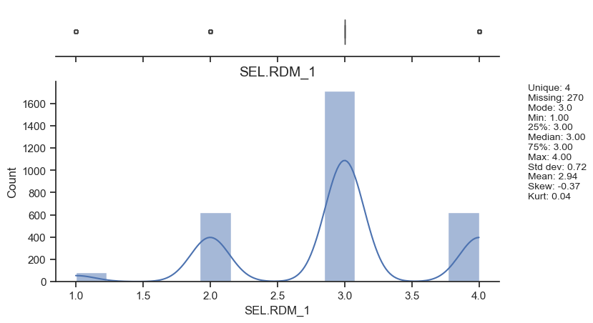Figure 27
SEL RDM Outcome 2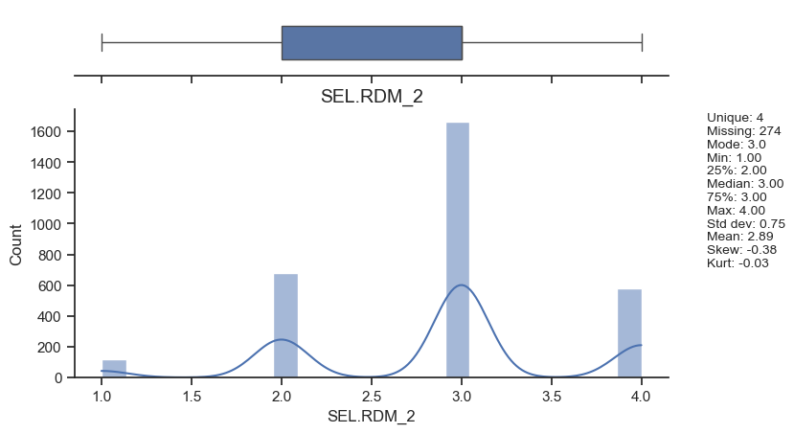

Figure 28
SEL RS Outcome 3
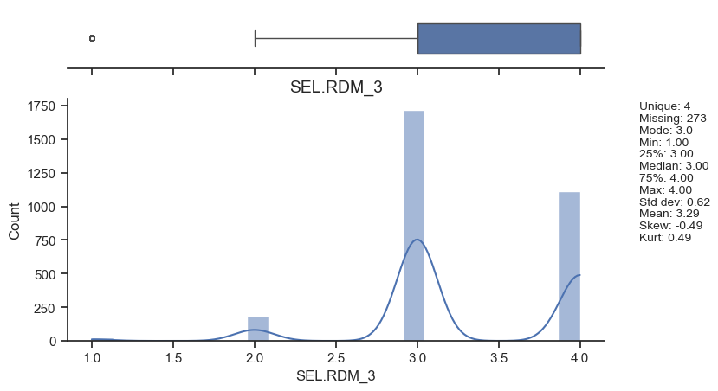

Figure 29
SEL RDM Outcome 4
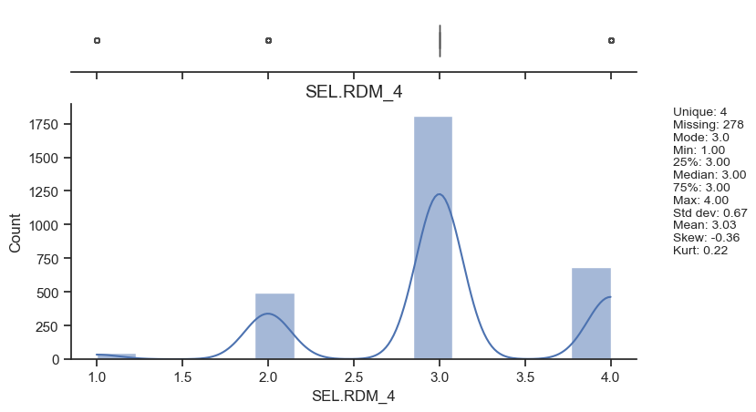

Figure 30
SEL RDM Outcome 5
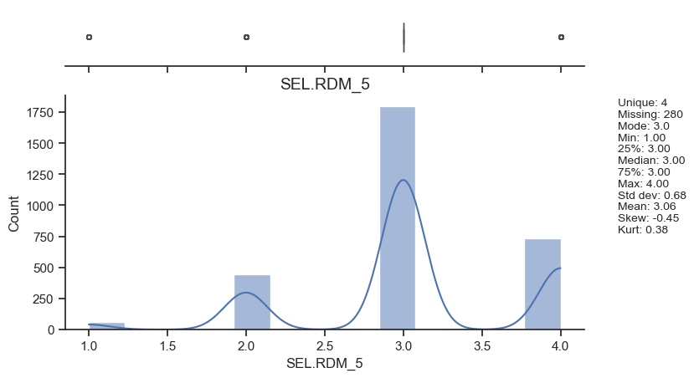

Verify Data Quality
With data aggregation, the largest issue created is that many of the rows of data have missing data, since not all of the student ID’s had data corresponding to SEL outcomes or mentor survey data. Only 382 mentor surveys were completed out of 3313. This makes 82% of missing data when data is integrated. Simpson’s paradox occurs when a third variable, called the confounding variable, creates a change in relationship between two variables (Frost, 2024). To avoid this issue, the subgroups of data were aggregated into one larger dataset, to see the effects of all variables on one another, including looking at the subgroups in the data without removing any confounding variables. One potential bias here then, is the issue of leaving out mentor survey data. Another bias is the mean imputation of missing values will only replicate any inherent bias in the dataset. The bias overall will be mitigated by looking at a smaller sample of complete cases with value imputation, which has the tradeoff of less data but of better quality.

Hypothesis Statements
The null hypothesis is there is no difference between the population of students with semester 1 enrollment and without semester 1 enrollment. The alternative hypothesis is that there is a statistically significant difference between populations with semester 1 enrollment and without semester 1 enrollment.

Data Diagnostics and Descriptive Summary
The data samples were decided after integrating the data, to verify if all of the data could be used, and if so, which subsets. These steps were performed first in R, one dataset at a time, integrated into one large dataset, then exported to Python for data diagnostics and data selection for progressing into model building.
Selected Data
The rows (records) selection included Demographics, Participation, and Enrollment with all rows containing a Mentee ID. The columns (attributes, features/label) selection included those with statistically significant p-values. These were significant p-values with effect size on sem1_enr, which represents a student that enrolled in the fall semester immediately after high school, which would be considered the Key Performance Indicator. When sampling the population, only those records with fully complete data can be used with the mentor survey data. However, leaving off the mentor survey data creates a much larger dataset. This is because the Mentor Survey Data Available only includes 382 Records. However, Demographics, Participation, and Enrollment records with data includes 3284 records, SEL Outcomes includes 3158 records. In removing NA values in this project and timeframe, I will use complete cases only, therefore removing the 752 NAs in the online_pair_completion_sr_yr and pair_mtgs_sr_yr.went back and removed the entire missing NAs before data integration. When merged, 2,296 records were utilized as the final sample utilized from the population. According to IBM (2024), the attributes chosen must be specifically relevant to the data mining goal, and those data should be selected for the data samples. This is the reason this sample was chosen, to support the analytics problem of looking at SEL outcomes and student demographic data on sem1_enr. Because the attributes selected all will contribute towards the final project to find the key contributors influencing on-time semester 1 enrollment, all attributes left in the integrated dataset will be considered at this time.
Data Cleaning, Integration, Formatting, and Construction
In R, before joining the four datasets together to create a larger integrated dataset, I removed all duplicate records that were exact matches, so that each mentee (student) had one single record. If not handled correctly, Nguyen explains that missing value imputation can significantly impact bias or data integrity (2025). He elaborates that:
“In causal inference or explanatory analyses, the primary objective is to ensure valid statistical inference, emphasizing unbiased estimation of parameters and accurate representation of uncertainty. The treatment of missing data must align closely with the assumptions about the mechanism behind the missing data—whether it is Missing Completely at Random (MCAR), Missing at Random (MAR), or Missing Not at Random (MNAR)” (Nguyen, 2025).

Methods for testing for MCAR data here include the following, according to Nguyen (2025), Little’s MCAR test and T-tests. When conducting the MCAR Little’s t-test, the null hypothesis was rejected that the missing data were MCAR with a p-value of 0.000, meaning that the data are either MAR or MNAR. Data Integration was handled by combining four tables that were integrated:
- Demographics, Participation, and Enrollment
- Mentor Survey Data
- Social-Emotional Learning Outcomes
- Mentor/Mentee Pairings
Demographics, Participation, and Enrollment Data
All fully empty rows or columns were removed during the data cleaning process. I identified three columns that have 1 NA value, and two columns have 800 NA values. Since the goal is to understand the relationships between student demographics, mentor communication, and SEL outcomes, there needs to be available mentor communication. This means any data that shows NA for online_pair_completion_sr_yr and NA for pair_mtgs_sr_yr will need to be removed when analyzing the data. For now, however, I want to keep these rows to combine with the other data since these mentees may be useful for analyzing SEL outcomes. However, I did end up filtering these rows out later, since they did not support the specific data mining goal. For the race/ethnicity variable, No Data will not be useful in looking at whether or not the race/ethnicity variable will have effect on semester 1 on-time enrollment, so it is a category that will be used, but cannot be explained except with the addition of other variables.
Social-Emotional Learning Outcomes
In the Social-Emotional Learning (SEL) outcomes attributes, each feature had “missing at random” data that was handled by imputation. I began by removing 30 complete duplicate values. Since there were entire rows of missing SEL outcomes other than user_id, those rows were completely dropped, which resulted in removing 107 empty rows. According to Nguyen (2025), Missing Completely at Random values means that the missing values are entirely at random, not related to observed or unobserved variables. In this case, synthetic nearest neighbor imputation can be a robust method for handling these missing values, rather than replicating any inherent bias in the data using the mean value imputation (Nguyen, 2025). However, for the initial exploratory data analysis, the mean value imputation was utilized. I decided that mean value deterministic value imputation due to simplicity and interpretability of the model, will only have a small effect size on overall bias due to only 1% of the data overall being missing.
Mentor Survey Data
In the Mentor Survey Data, 29 NA Values in Pair ID and Mentor ID meant that these rows needed to be removed since they could not be associated with any other records. Feature engineering by pivoting data first for mentor communications based on the Pair ID, Mentor User ID, Mentee ID, and how many times they communicated, along with each type.
Mentor/Mentee Crosswalk
The Mentor/Mentee Crosswalk, which is a table useful for connecting the other three tables during the data integration phase, showed Columns 4-7 as completely empty except for a duplicate row in the wrong spot for Pair ID 72003. I removed columns 4-7 to avoid having errors with data quality, because these columns did not represent attributes. Then, I renamed the column values for joining to the other data sets during the data integration phase in this data preparation step.
Data Formatting
Any blank cells or those that had NA were converted to NA’s in R. Formatting percentages in the same format - instead of 99 and 0.99 representing 99%, both were converted to decimals representing percentage. For the data modeling phase, a few of the variables will require additional transformation. For example, because Skewness is too high with the # of Mentors variable, a Box-Cox Transformation will be used along with normalization prior to training a MLR model. Additionally, the categorical variables will be feature engineered into individual features using dummy variables of 0 or 1 to represent the record as having or not having the particular attribute.
Data Reliability
I looked at each variable’s unique values to understand the different categories or values in each attribute. Data distributions included looking for outliers using data visualizations (boxplots, scatterplots, and histograms with kernel density plot overlays). In the SEL outcomes data table, 30 of the user_id columns were duplicated. This indicates that either the students took the SEL outcomes survey twice, or the user id is incorrect. Since there is such a small number of these datasets, the first will be kept only, to retain the information, and the 2nd will be removed.
Addressing Problems with Data
One large problem to address was out of place data in that the header row was a description of the header rather than each column header being the name of the feature. In the Social-Emotional Learning Outcomes data table, the first row contained duplicate variable names, which were then removed. In the SEL Outcomes table, the “-99” value in each attribute (all attributes, since all were survey data) was replaced with “NA” since the values for each attribute were only to be represented by 1, 2, 3, or 4 (discrete, ordinal, numeric data). Data typing issues such as: numbers stored as text in pair_mtgs_snr_year, text stored as a number is “year”, or ordinal data not stored as a factor were addressed. Additionally, user_id, mentor_id, and pair_id were changed to strings as text data, due to not being numeric data. NA values were handled because these were not useful within the dataset. With the 0 matches in LOM Control Matches attribute, all of these were removed as an outlier. In the Mentor survey data, there were NA values where mentor communication was not present. These were changed to “None” in order to signify no contact attempts were made during that time frame.
Simpson’s rule, Anomalies, and Segmentation
With the 0 matches in LOM Control Matches attribute, all of these were removed as an outlier. The data was segmented according to the binary label, which showed two distinct samples within the population: those who enrolled in a university the fall semester after graduation from high school, and those that did not. Anomalies in the Mentor/Mentee pairs were kept, because this could reasonably represent a few Mentor/Mentee pairs that met a lot, but may not have had much progress, or needed to meet to continue making progress. These were kept. Simpson’s rule was looked at by understanding the confounding variables going into the analysis (Norton & Divine, 2015). Stratifying the data, such as looking at the semester 1 enrollment by race, each race, and each gender, provides a more useful look at the data to see if any trends occur that are reversed when aggregated.

Exploratory Data Analysis
During the data analysis, the semester 1 enrollment was looked at in regards to each one of the variables. Table 4 shows the statistics and their effect on the sem1_enr variable. The exploratory analysis shows that the p values for the following variables contributed with statistical significance towards sem1_enr: school, gender, LOM (control matches), pair_mtgs_sr_yr, online_pair_completion_sr_yr, matched_sixmonths, cohort, SEL.GM_9, SEL.GM_4, SEL.GM_5, and SEL.RDM_5. This utilizes logistic regression bivariate analysis to understand the statistical significance of each feature on the label, because the label is a binary variable. The linear relationship of the feature to the logit (log odds) of the label variable shows the strength (coef or X2), direction (negative or positive), and significance (p-value) of each individual feature in contributing to the prediction of the label.
Table 5
Bivariate Analysis of sem1_enr
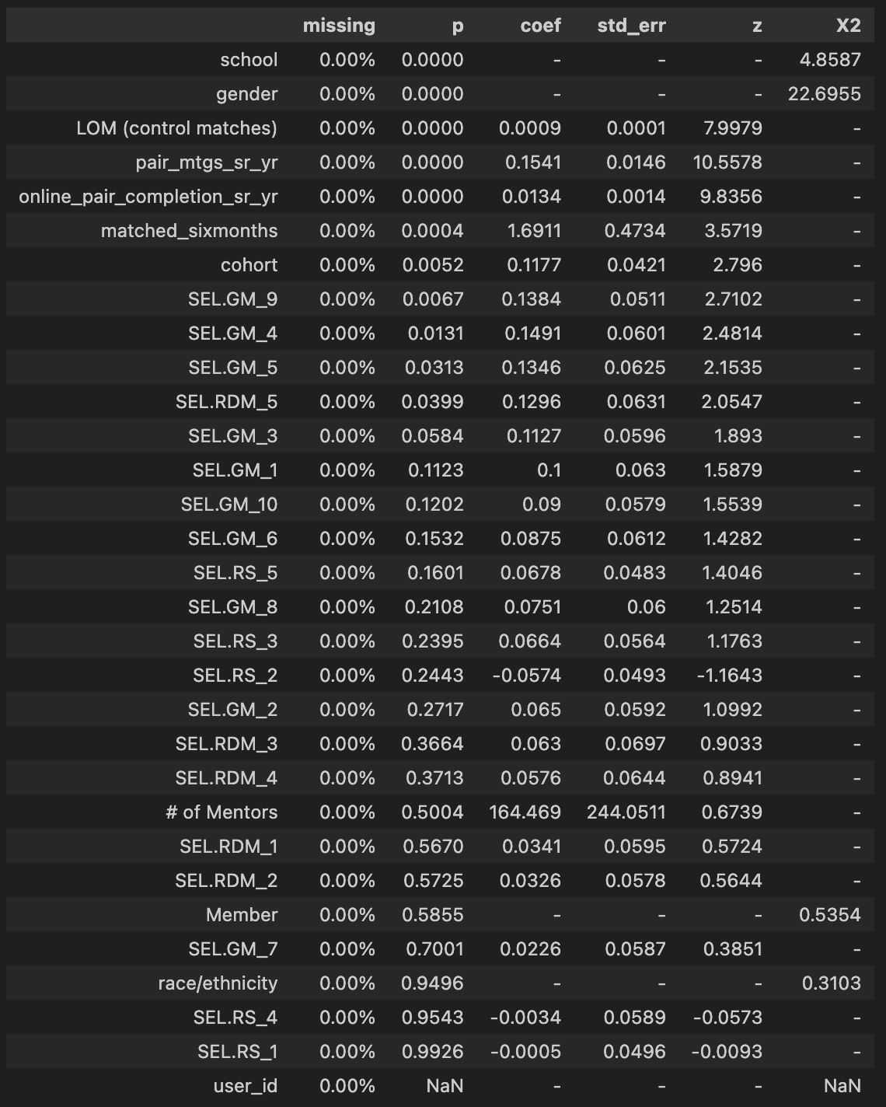

Trends Analysis
The trends analysis between sem1_enr and each other variable included visualizing the data in Tableau to understand the trends. What is the effect of cohort on sem1_enr? The trend shows that even with a higher count of sem1_enr in 2021, the percentage of students with sem1_enr in 2020 was higher than for all other cohorts.

Figure 31
Semester 1 Enrollment by Cohort
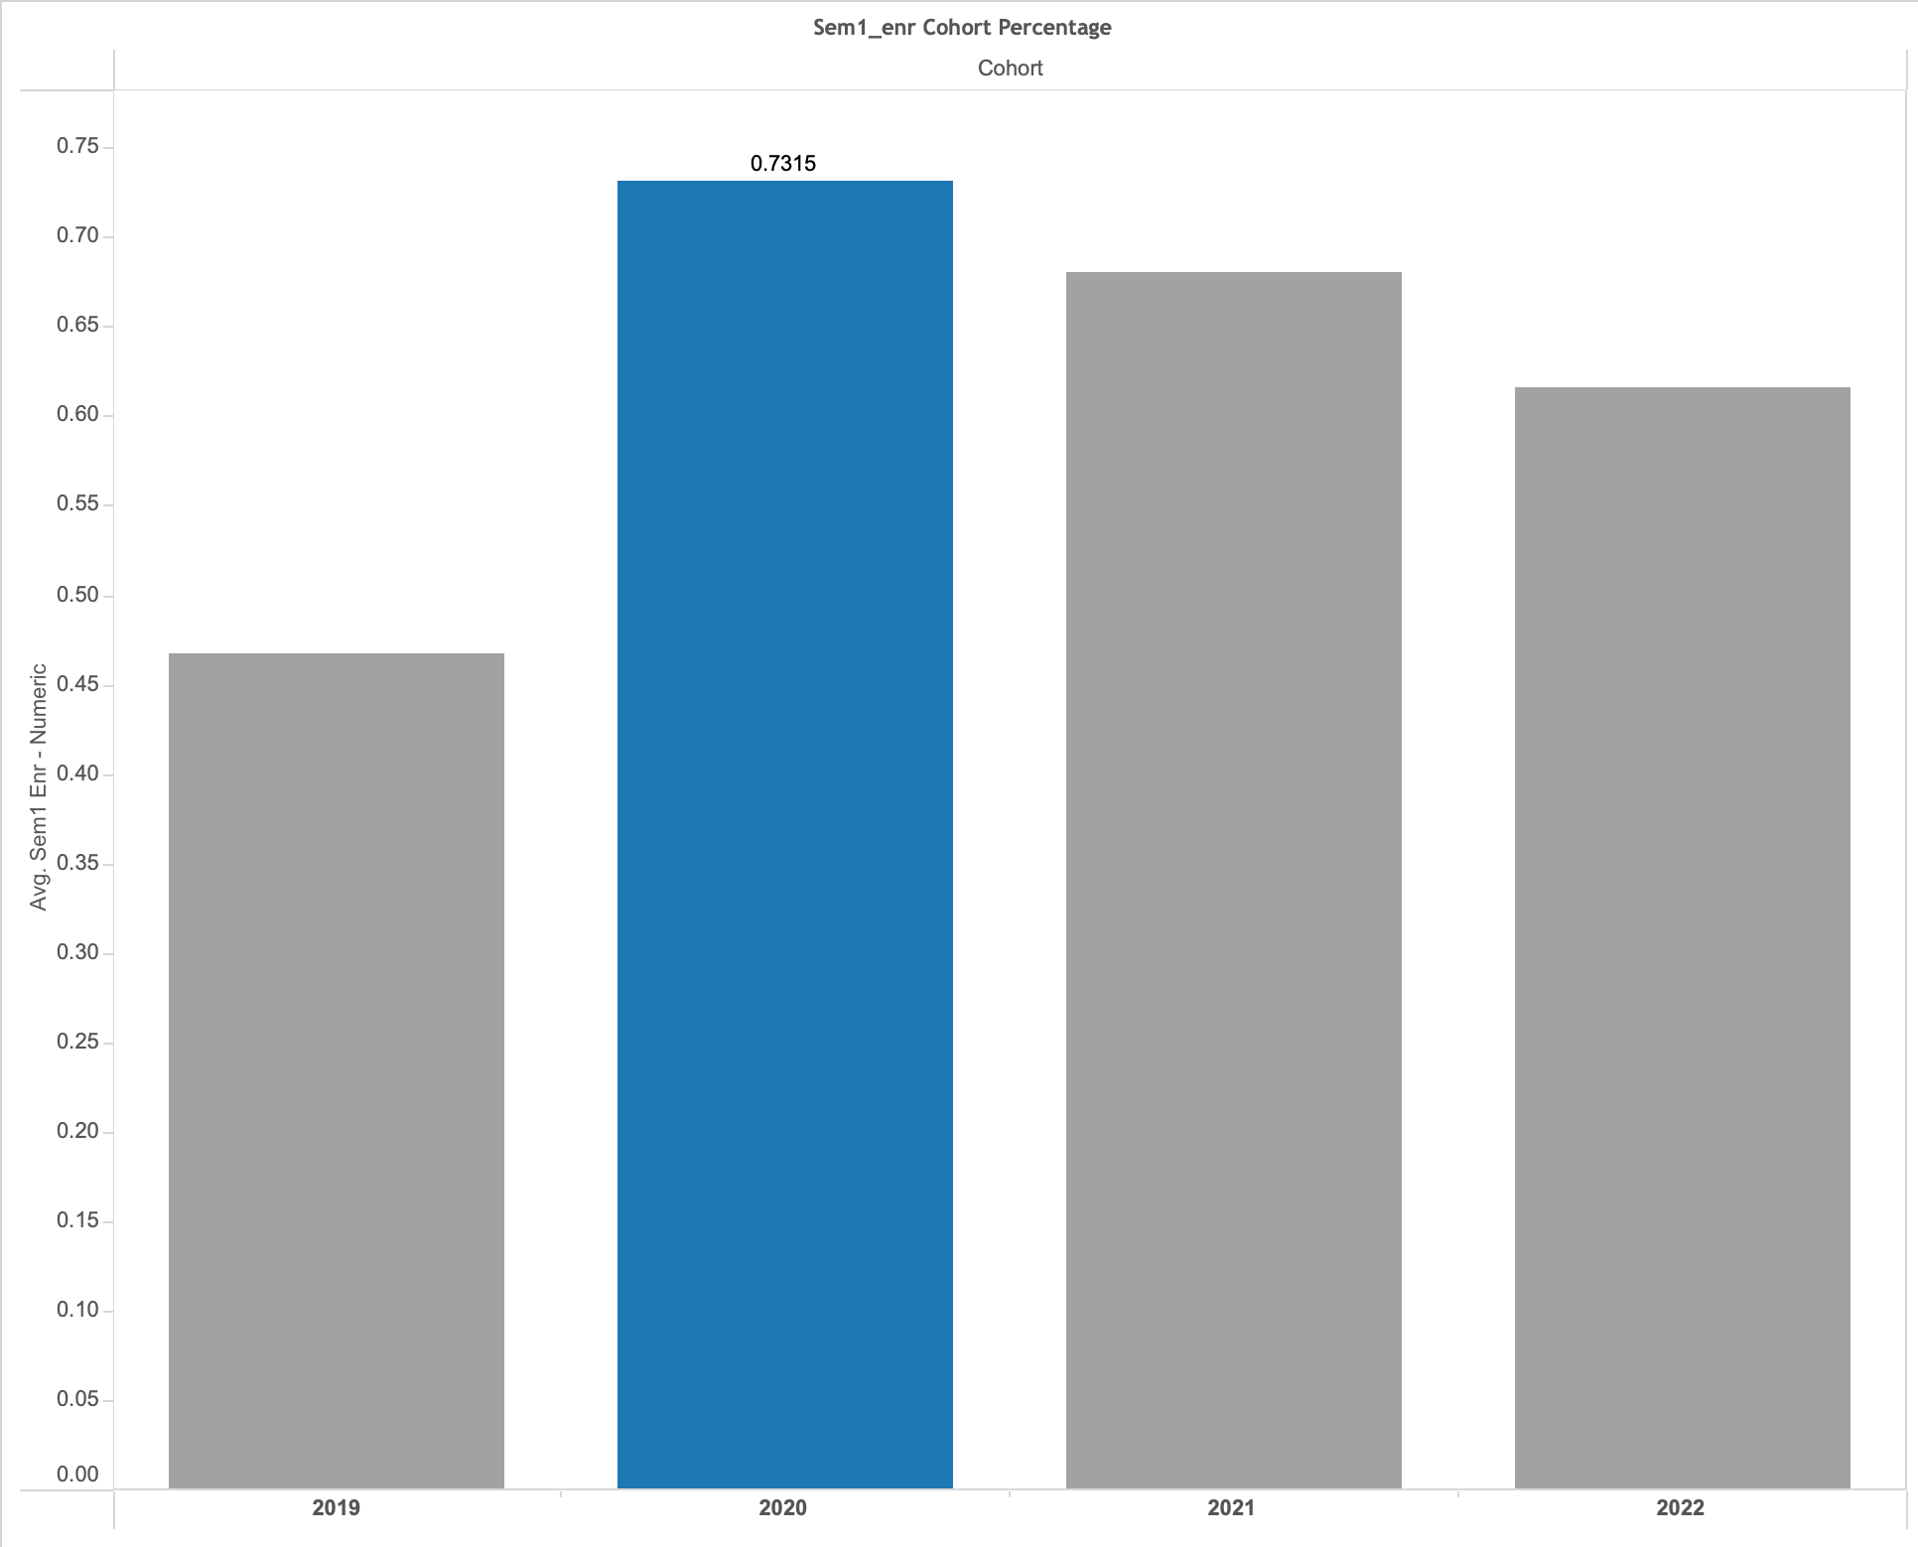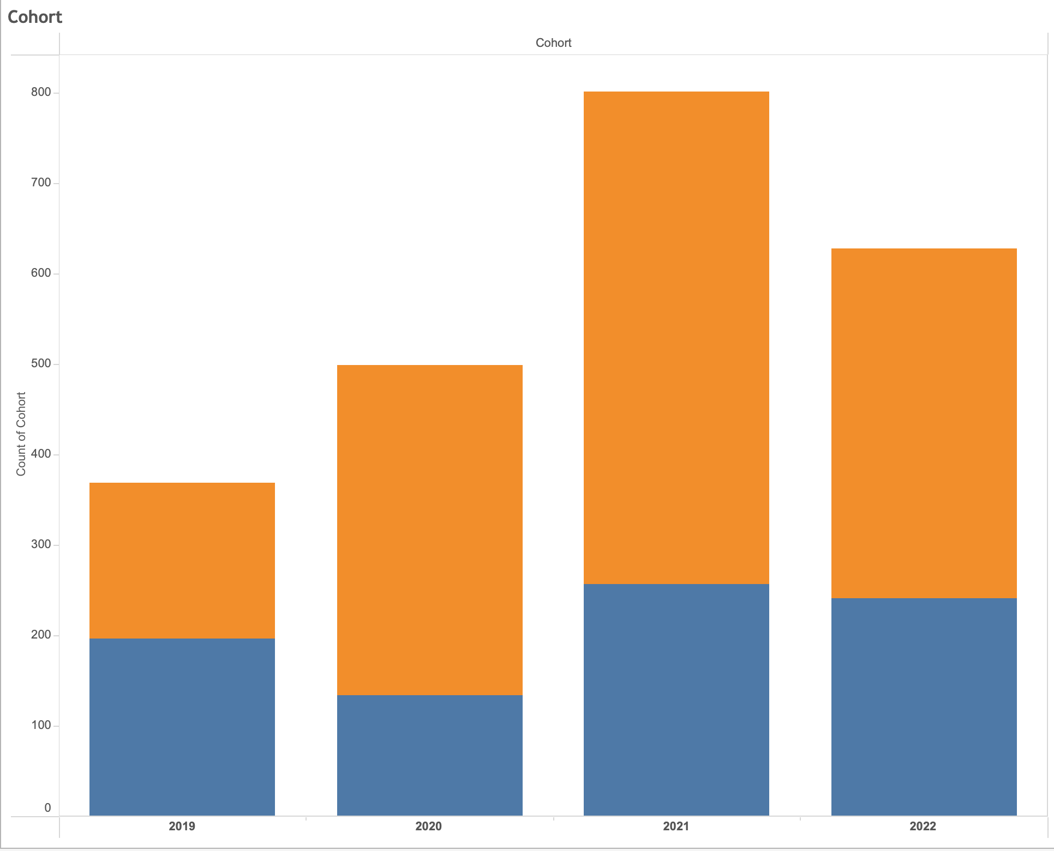
Note: The average percentages (left) and proportions (right) indicate that even with higher enrollment overall in 2021, the 2020 cohort showed a higher proportion of enrollments, while 2019 had the lowest proportion and overall program participation.

Figure 32
ANOVA on Sem1_enr by Cohort
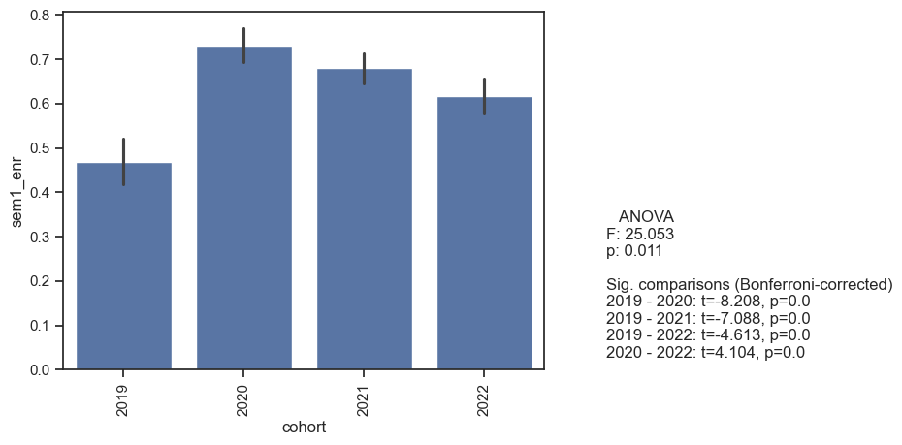
Figure 32 describes cohort with statistical significance between each sample of the population means, showing a p-value of 0.011 and the Bonferroni-corrected comparisons when running multiple t-tests, signifying which specific comparisons had the highest t-statistic and most significant p-value. All of the comparisons have statistical significance between the cohorts. This means we can reject the null hypothesis that there is no statistically significant difference between cohorts, and instead accept the alternative hypothesis that there is a statistically significant difference between each of the cohorts. Additionally, the F-statistic shows the large effect size, 25, of the contribution of cohort giving to the prediction of the label.

Figure 33
T-Test of Gender on Sem1_enr
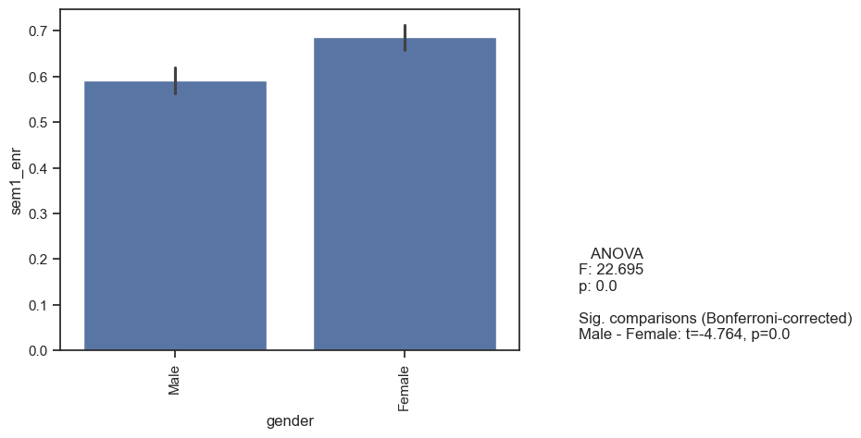
We can reject the null hypothesis that there is no statistically significant difference between male and female mentees. This means that more Female mentees have a statistically significant amount of immediate college enrollment, with a large F-statistic of 22.7, than Male students do, and that the alternative hypothesis is accepted.

Figure 34
Pair Completion Senior Year Trend Analysis
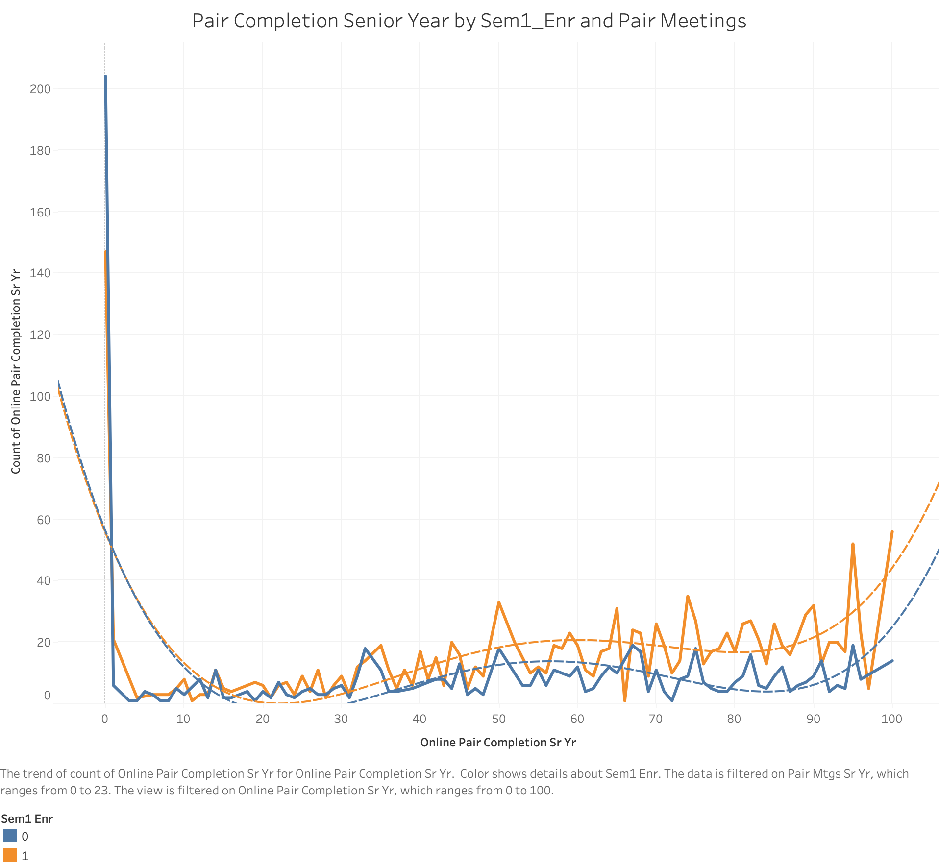
The trend analysis indicates that there are two significant findings:
- That online pair completion senior year had statistically significant differences in the population means.
- That the trend designates a 4th degree polynomial relationship with sem1_enr.
The R-squared statistic shows a value of 0.310026, meaning that 31% of the variance between sem1_enr can be explained by Online_pair_completion_sr_yr.

Table 6
Trend analysis of sem1_enr = 0
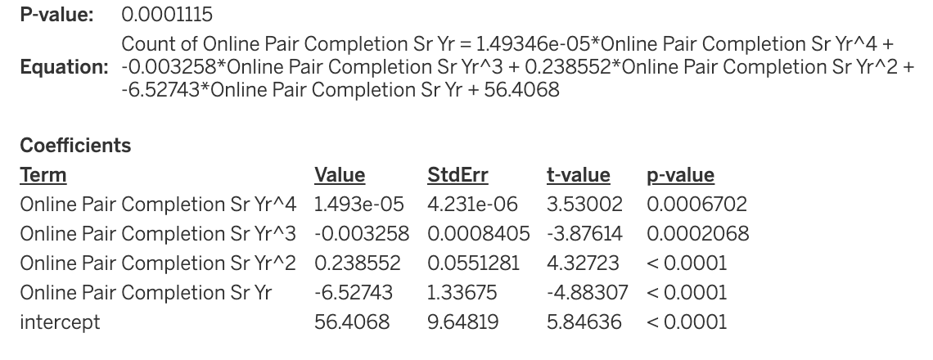

Table 7
Trend Analysis of sem1_enr = 1
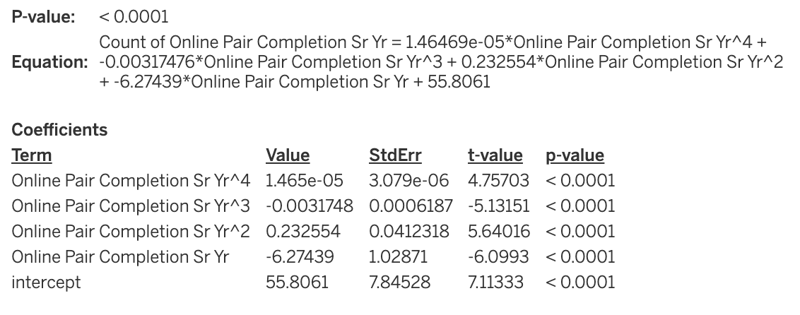
When Pair meetings senior year was adjusted using a filter, to include all numbers of meetings except 1, the R-squared value jumped up to 0.580416 with a p-value <0.0001. This is shown below in figure 35.

Figure 35
Pair Meetings Senior Year Filter on sem1_enr and Online Pair Completion
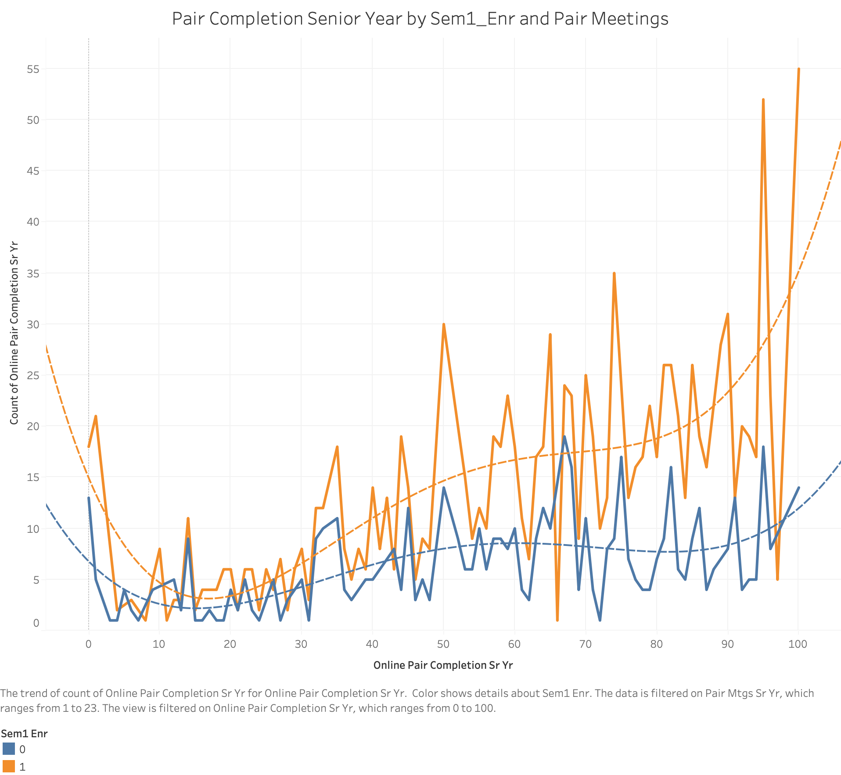
Note: online pair completion senior year and pair meetings senior year also had high correlation.

Figure 36
ANOVA for pair_mtgs_sr_yr and sem1_enr
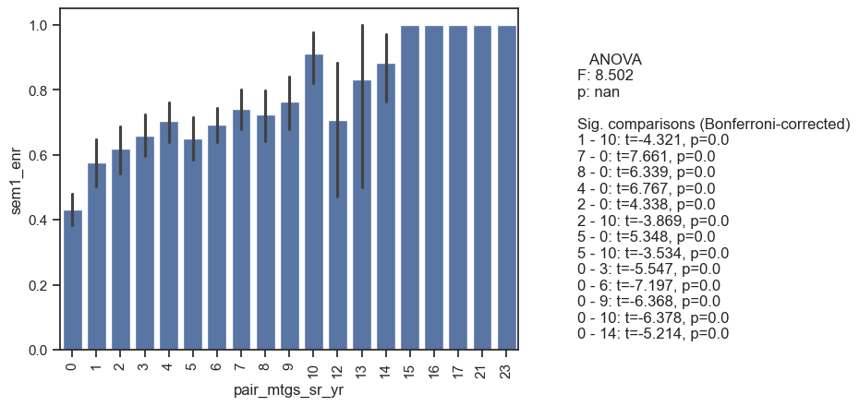
Descriptive Analytics

Figure 37
Semester 1 Enrollments
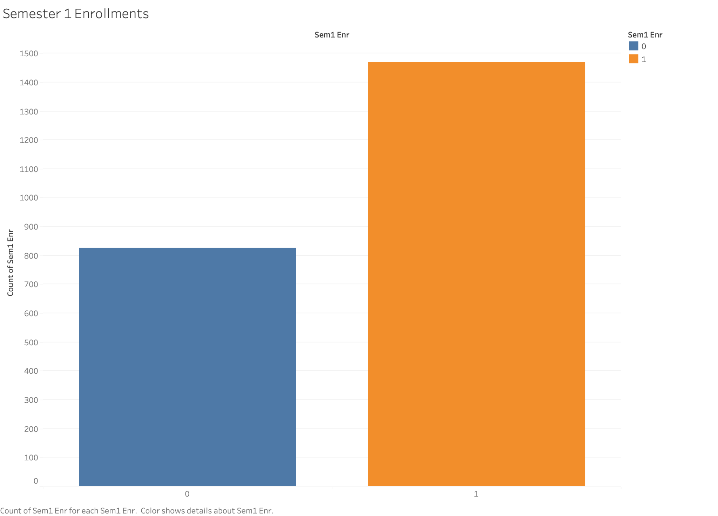
More students had an enrollment in the next semester for Fall into college than those that did not. This is how the data is segmented.

Figure 38
Fall Semester Enrollment in College by Gender
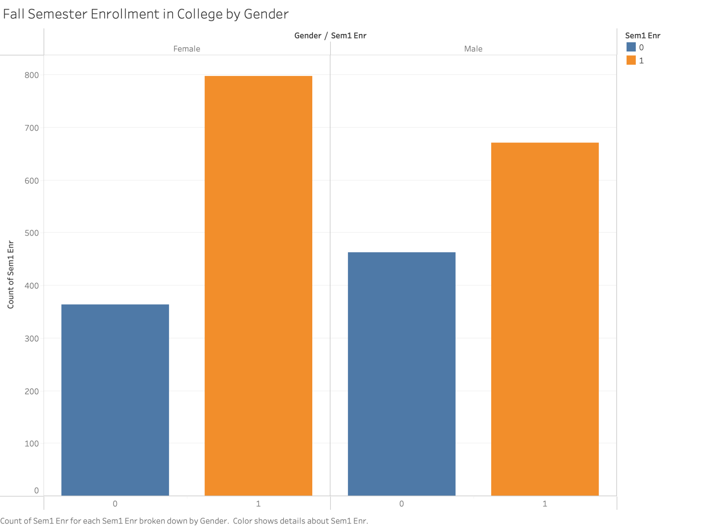
Race/Ethnicity was looked at to see if it had any statistical significance as a categorical variable on the Sem1_enr. When running the analysis, there is not a statistical significance using ANOVA for any particular Race/Ethnicity. This means that there is no meaningful differences amongst race/ethnicity in sem1_enr.

Figure 39
Race/Ethnicity Effect on Sem1_enr
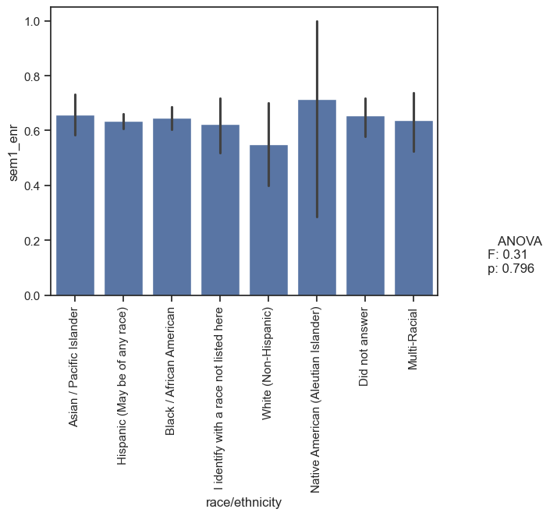

Figure 40
Semester 1 Enrollment by Mentor/Mentee Six Month Matches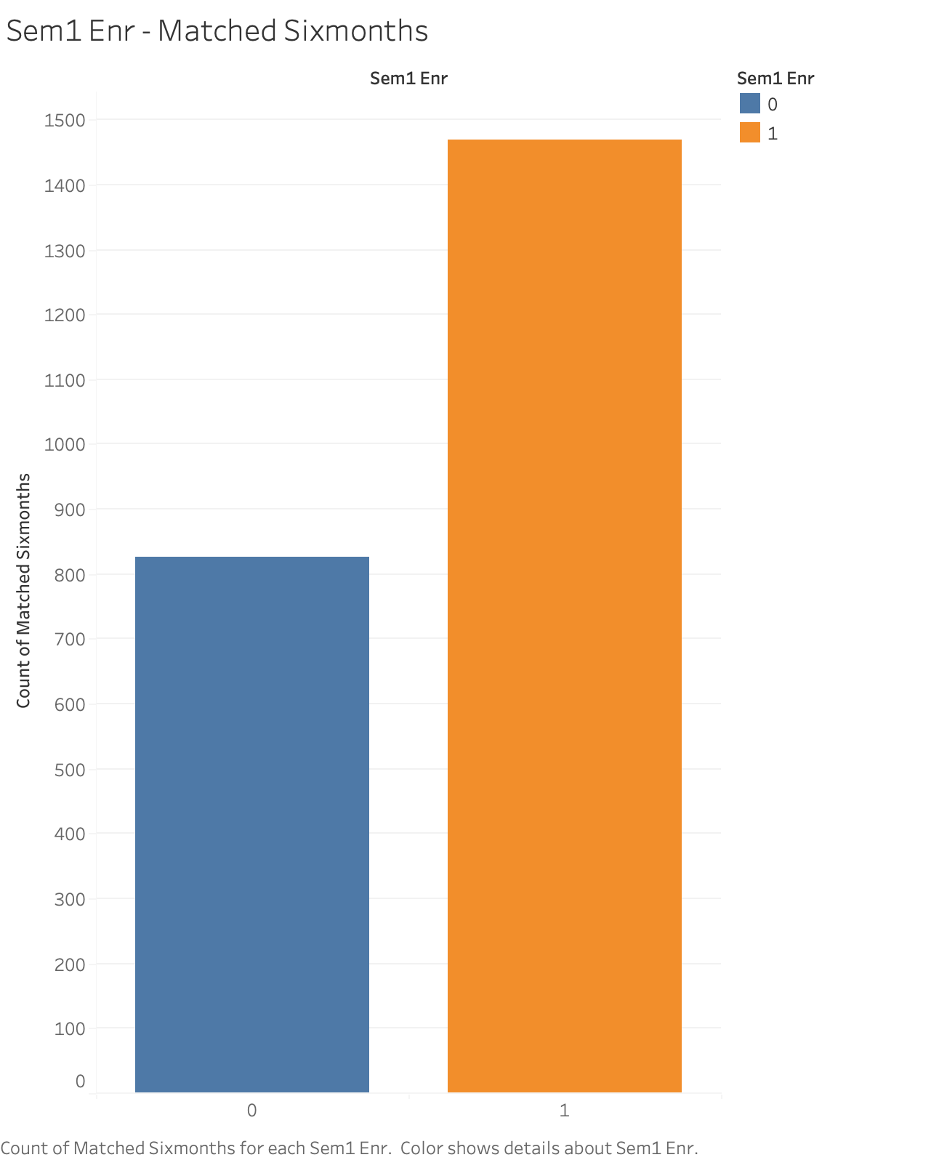

Figure 41
ANOVA for matched_sixmonths

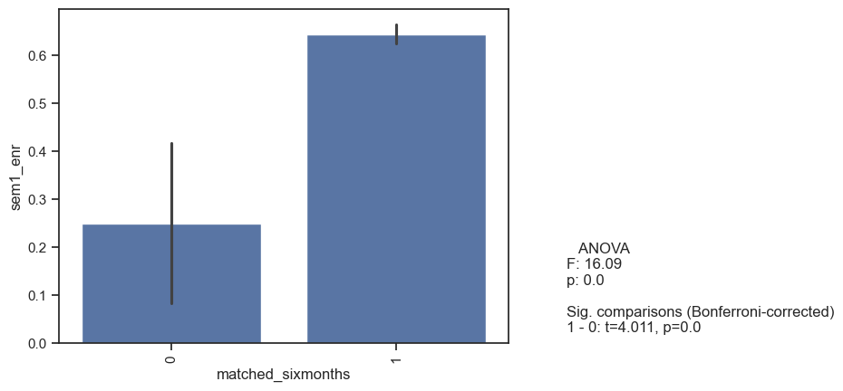
Matched_sixmonths was verified to also have statistical significance between the two populations, meaning that those who had matched_sixmonths as “yes” or “1” were more likely to enroll semester 1 in Fall for college.

Figure 42
LOM Control Matches
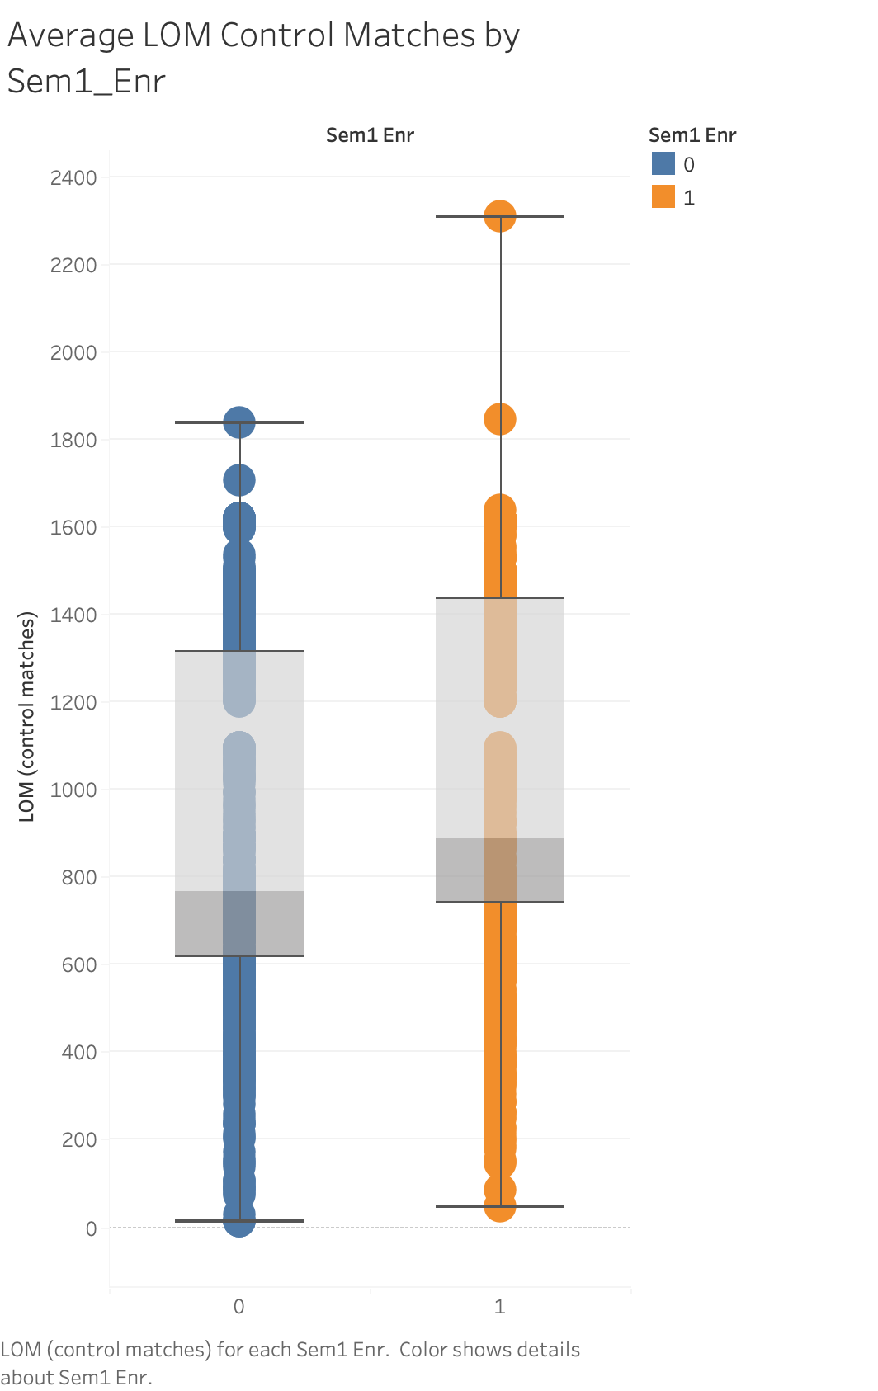
Since LOM (Control Matches) had a statistically significant effect on the sem1_enr, this was also verified using hypothesis testing to statistically ensure that there was a significant different between the two population samples. This was found to reject the null hypothesis that there was not a statistically significant difference between the two populations.

Figure 43
Sem1_enr by School and Gender
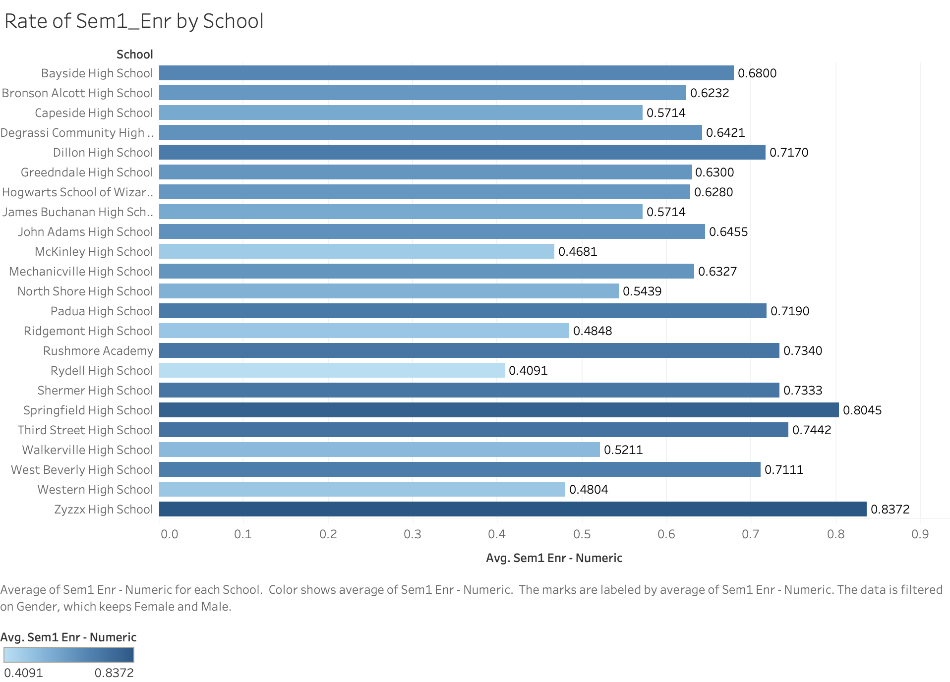

Figure 44
SEL Trends Analysis by Sem1_enr Average Rate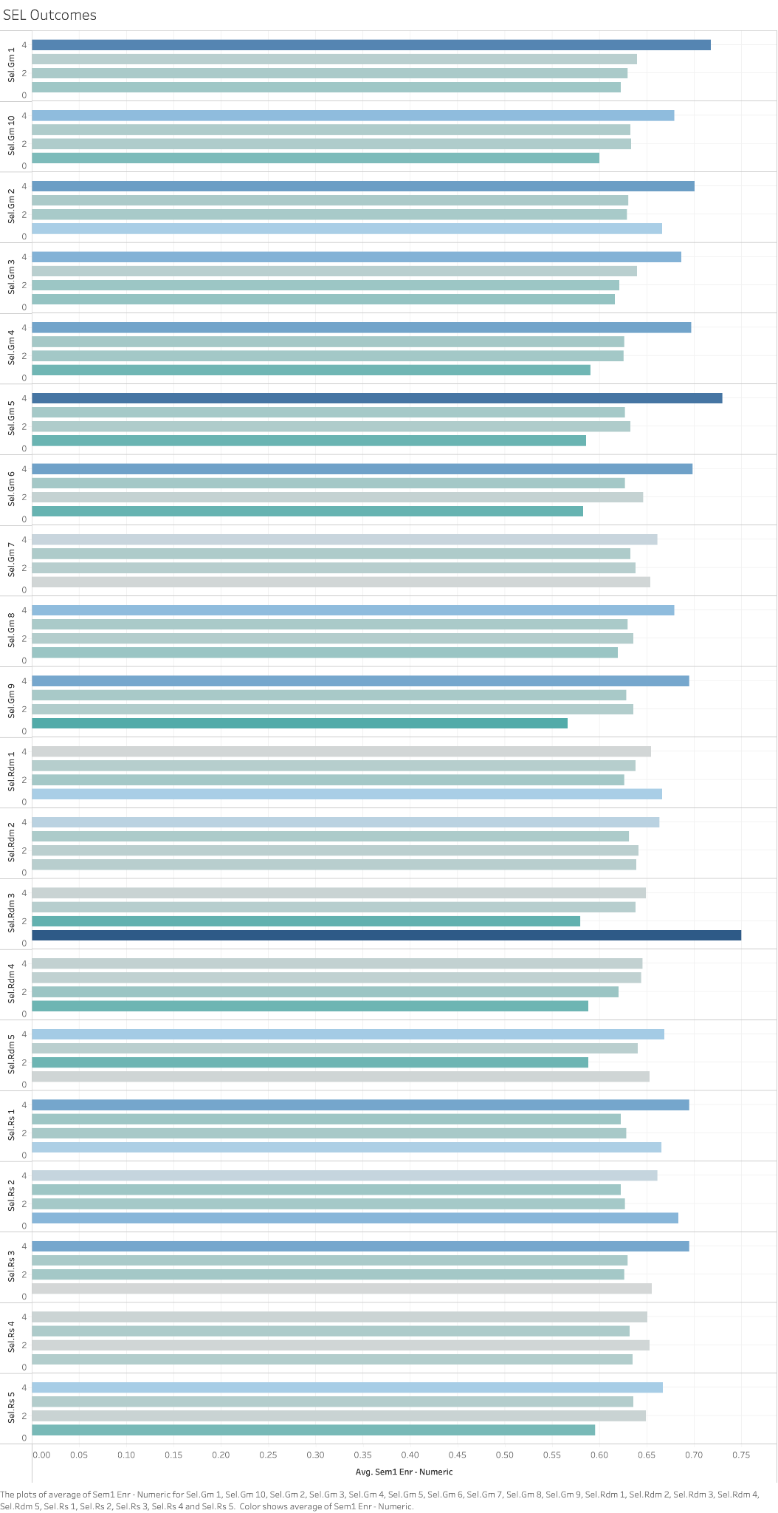
Verify Data Quality
Once all the data was aggregated, it was analyzed by breaking down each category, group, and numeric bin to look at each effect on the binary outcome variable of semester 1 enrollment. Multiple side-by-side charts were utilized during this process, along with creating a dashboard in Tableau to help prevent Simpson’s paradox. For example, when segmenting the groups into schools, a very interesting trend occurred in the data that showed each school had a different percentage of sem1_enr on average, rather than all data not segmented. Norton & Divine (2015) give a short list of how to plan for preventing Simpson’s paradox, with one glaring component of prevention being conducting statistical analysis to check for confounding. One way to do this is to split up a sample into its non-aggregated groups (such as splitting by gender for each school) and then completing t-tests or ANOVA tests.
Conclusion
Conclusions include the following:
- There is a statistically significant difference between sem1_enr “no”, represented by 0, and “yes” represented by1, to reject the null hypothesis that there is not a statistically significant difference between the two samples with the population.
- The statistically significant contributing variables in predicting sem1_enr include: school, gender, LOM (control matches), pair_mtgs_sr_yr, online_pair_completion_sr_yr, matched_sixmonths, cohort, SEL.GM_9, SEL.GM_4, SEL.GM_5, and SEL.RDM_5.
- The Tableau dashboard below can be deployed for future data understanding, data sampling, and further exploration by cohort, gender, school, pair completion, and by race/ethnicity.
- Cohort 2020 would be an excellent sub-sample of the population to create a specific predictive model on, and can be explored in future data mining projects.

Figure 45
Tableau Dashboard
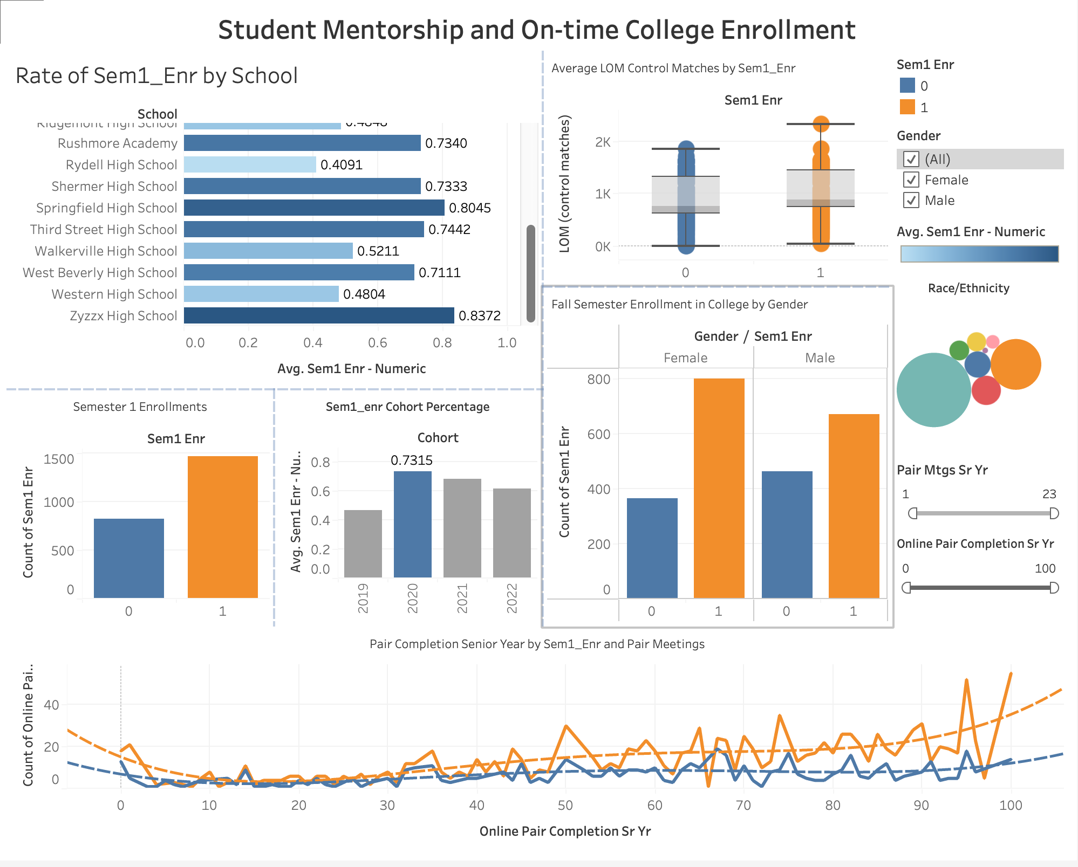
Because each of those features was found to have statistically significant contributions to the sem1_enr, each was tested to support the alternative hypothesis that each sample within the population for each variable did have a statistically significant difference between population means. The type of school and specific school the student was associated with, the gender being female, the LOM (Control Matches) being higher, the number of pair_mtgs_sr_yr being higher, the online_pair_completion being higher, having a yes to being matched six months, the cohort of 2020, goes to Zyzzx High School, and the higher the scores on SEL.GM_9, SEL.GM_4, SEL.GM_5, and SEL.RDM_5, all would represent a causal relationship between the variables and sem1_enr = yes. This is a “prototypical” record for a mentee who will have sem1_enr = yes.

Methodology Approach and Model Building
Why Logistic Regression? Logistic Regression is a type of machine learning predictive method that evaluates the probability of the outcome variable being classified as either 0 or 1, falling between 0 and 1 using the sigmoid function. The model will utilize the maximum log likelihood estimator to choose which records are classified into each class of 0 or 1 (Ellison & Deeke, 2021). Because the outcome variable in this project is a binary variable on whether the student had on-time college enrollment the semester after graduation from high school, the logistic regression method was chosen to classify each student into a 0 = did not enroll, or 1 = did enroll. Additionally, XGBoost, XGBoot Random Forest Classifier, Support Vector Machines (SVM), and K-Nearest Neighbors (KNN) are all explored to determine best model fit prior to calibration and validation.
Model Assumptions
Logistic Regression also best addresses the following business problem because it satisfies the assumptions of a logistic regression model. These assumptions are as follows:
- Binary Classification problem - two variables (Brownlee, 2023).
- Outlier removal so that the model does not have any “noise” in the data for training the model.
- The observations are independent of one another.
- There is little to no multi-collinearity to avoid overfitting the model, which logistic regression is prone to overfitting (Brownlee, 2023).
- There is a linear relationship between explanatory variables and the logit of the response variable (Bobbit, 2020).

Modeling Methods
Since the model satisfies binary classification as the predictive outcome of the modeling phase, logistic regression was chosen. Outlier removal took place during the data preparation phase, in order to ensure that each variable maintained a normal distribution without any additional noise. Only a few outliers such as errors in the data and extreme cases were removed, rather than kept. For observation independence, each observation was gathered independently from one another, so this assumption was satisfied. Multi-collinearity was addressed utilizing the Variance Inflation Factor (VIF). VIF is defined as quantifying the level of multicollinearity by measuring the variance increase of a regression coefficient affected by correlation between variables (GeeksforGeeks, 2025).
Feature Selection
VIF was utilized for feature selection. Once each feature was tested for meaningful statistical significance between samples of a population in the Exploratory Data Analysis (EDA), VIF was then used to eliminate any of the specific features that had too high of a VIF with a threshold set at <5.0. Below, VIF scores were initially calculated to account for multicollinearity, to satisfy the assumption of no multicollinearity for a logistic regression model.

Table 8
Snippet of Initial VIF Scores
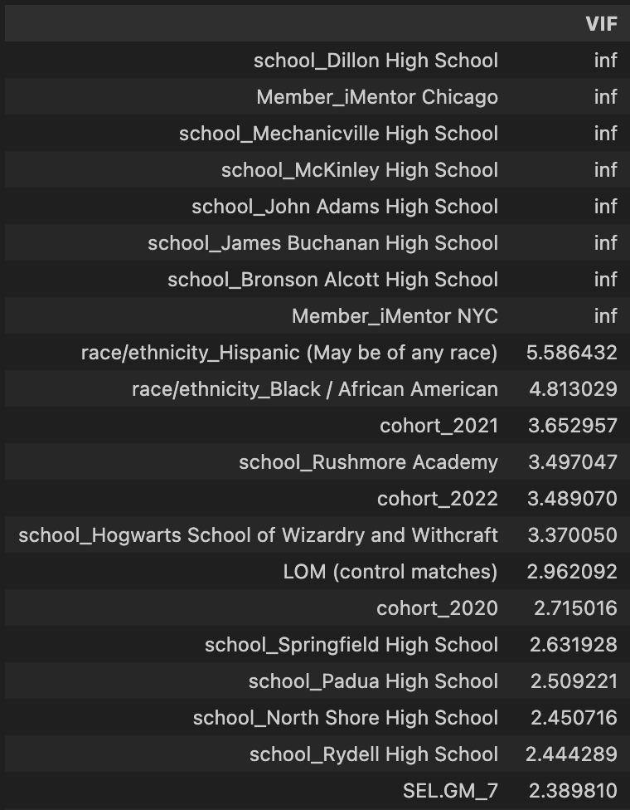

The VIF Scores here show several that say “inf” which means they have perfect 1.0 correlation with another variable. Due to this, a function was created to iterate through and remove one feature at a time, recalculate VIF scores, and then run the model again with another feature removed, and so on. In Figure 8 below, the features were selected based on VIF scores.

Table 9
Snippet of VIF Scores with Removed Multicollinearity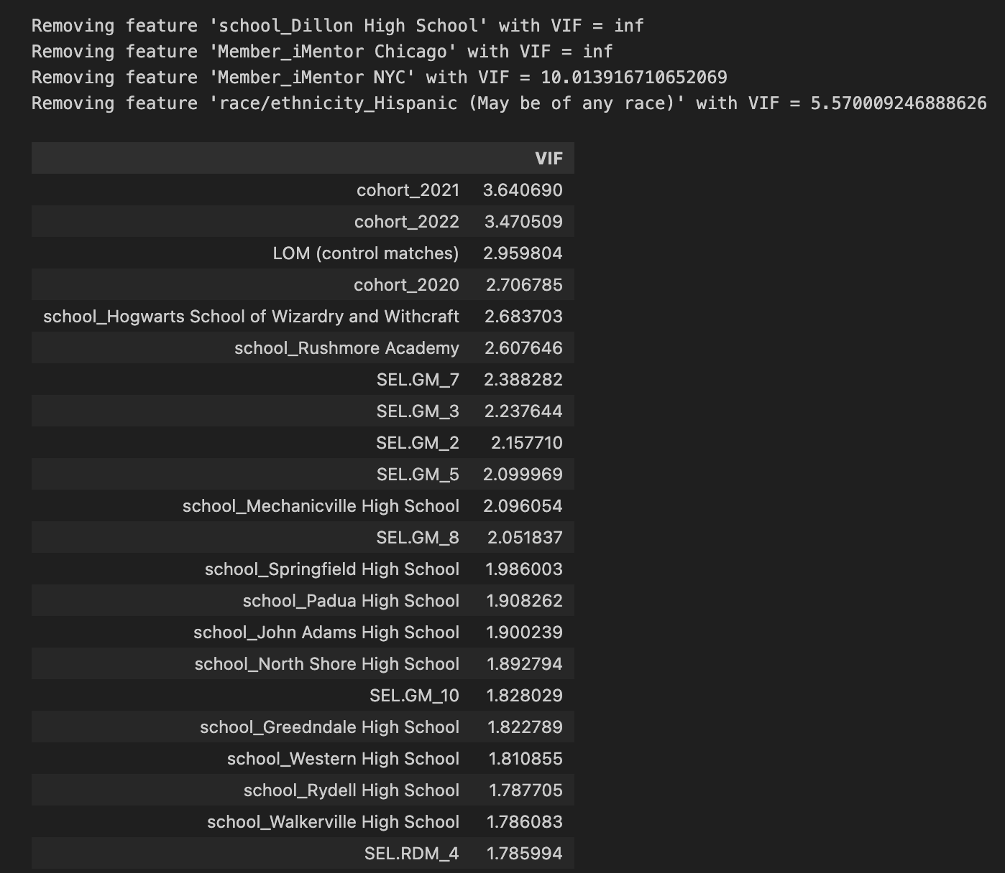
The features that were taken out due to VIF above 5.0 were ‘school_Dillon High School’, ‘Member_iMentor Chicago’, ‘Member_iMentor NYC’, and ‘race/ethnicity_Hispanic (May be of any race)’. The features exhibited too high of VIF scores, and once removed, left the model ready with low multicollinearity, satisfying the assumption for training a logistic regression model at this point. Additionally, features were selected after running the model the first time, only to include variables that had p-values < 0.05, meaning they were statistically significant in contributing to the model. The specific process for selecting these occurred during the model building.

Test Design and Model Building
The accuracy of the model was formed by first fitting the logistic regression model utilizing the standardized numerical variables. Standardization, according to Frost (2018), will help with identifying multicollinearity, while also avoiding overfitting to increase reliability, robustness, and accuracy of the model. The model is robust because feature selection has been completed, the VIF has been addressed, and all variables are included that have statistical significance. Additionally, the design of the test here is to look at the expected accuracy of predicting on-time college enrollment of high school seniors the fall after graduation is 69.4% (Soland, 2013). The Logistic Regression model was fit and assessed to expect at least this high of an accuracy in predicting enrollment. The variables of 'LOM (control matches)', 'online_pair_completion_sr_yr', 'pair_mtgs_sr_yr', and 'SEL.GM_9' had the statistical significance in this model, which still yielded a 67% overall accuracy.

Model Assessment & Intended Plan for Training, Testing, and Evaluation
The plan here for training, testing, and evaluation of the model will include partitioning the dataset by using the train, test, split method, along with k-fold cross-validation techniques to further enhance the model. This will ensure there is no model overfitting occurring. Evaluation of the model will be done through utilizing the confusion matrix and classification report, with the metrics of precision, recall, F1 score, accuracy, and weighted average. The most important metric for evaluation is recall, because the intention of the analytics problem is to identify the mentees who will most likely have a positive outcome, enrolling on-time in college. The model outcome after model fitting, to create an accuracy, precision, recall, and F1 scores had an overall accuracy of 67%. Figure 45 below shows a confusion matrix with the precision, recall, and accuracy score for the logistic regression model using train, test, split data for training and testing the model, using 80% of the data for training and 20% of the data for testing.

Figure 46
Logistic Regression Model Confusion Matrix 1
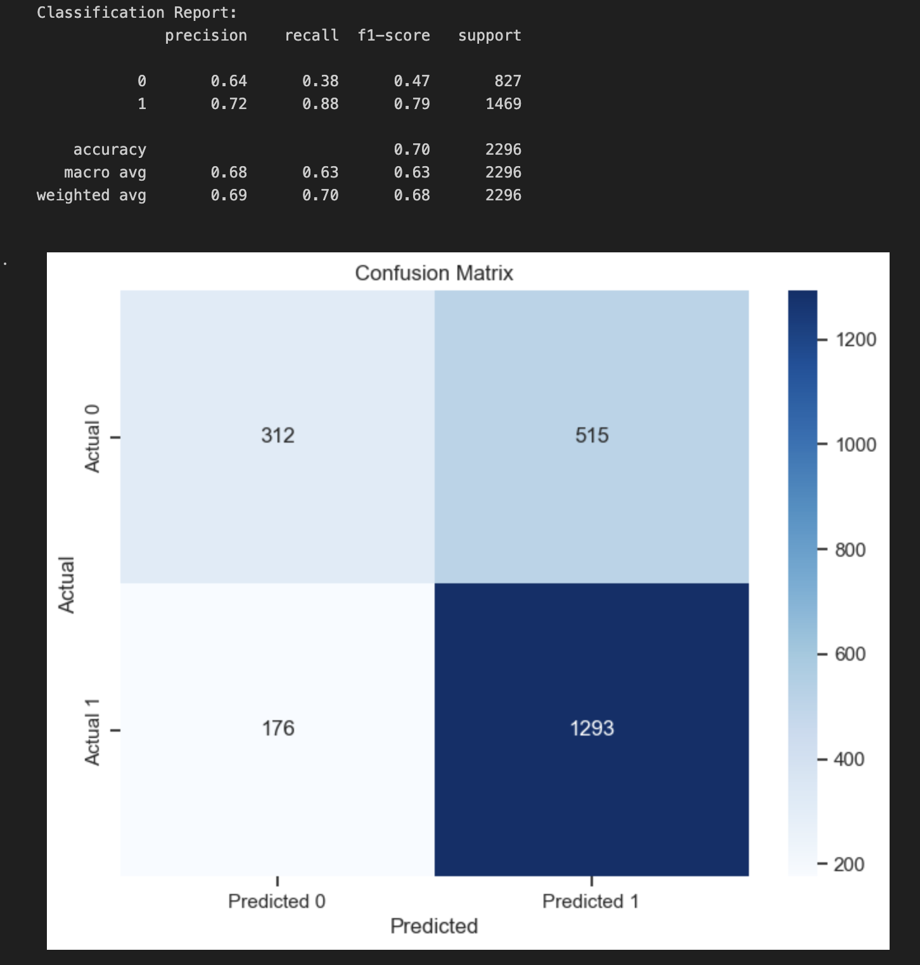
It can be seen that 1293 mentees were correctly predicted as actually enrolling in college. This means out of all the students the model predicted would enroll, 72% of the students who enrolled as yes were actually correct (precision metric). Recall for the was also shown, which can be interpreted as for all of the students who actually did enroll, 88% of the students who were predicted to enroll were correctly classified. The harmonic mean of the precision and recall here, which is the F1 score shows 79%, for the target variable of predicting enrollment to be “yes” or 1.
XGBoost, XGBoost Random Forest, SVM, and KNN were also fit, tested, and produced with classification metrics. XGBoost Random Forest had the best model performance, but did not outperform the Logistic Regression model. The metrics below are shown for the initial model fits.
Table 10
XGBoost Initial Classification Metrics and Confusion Matrix
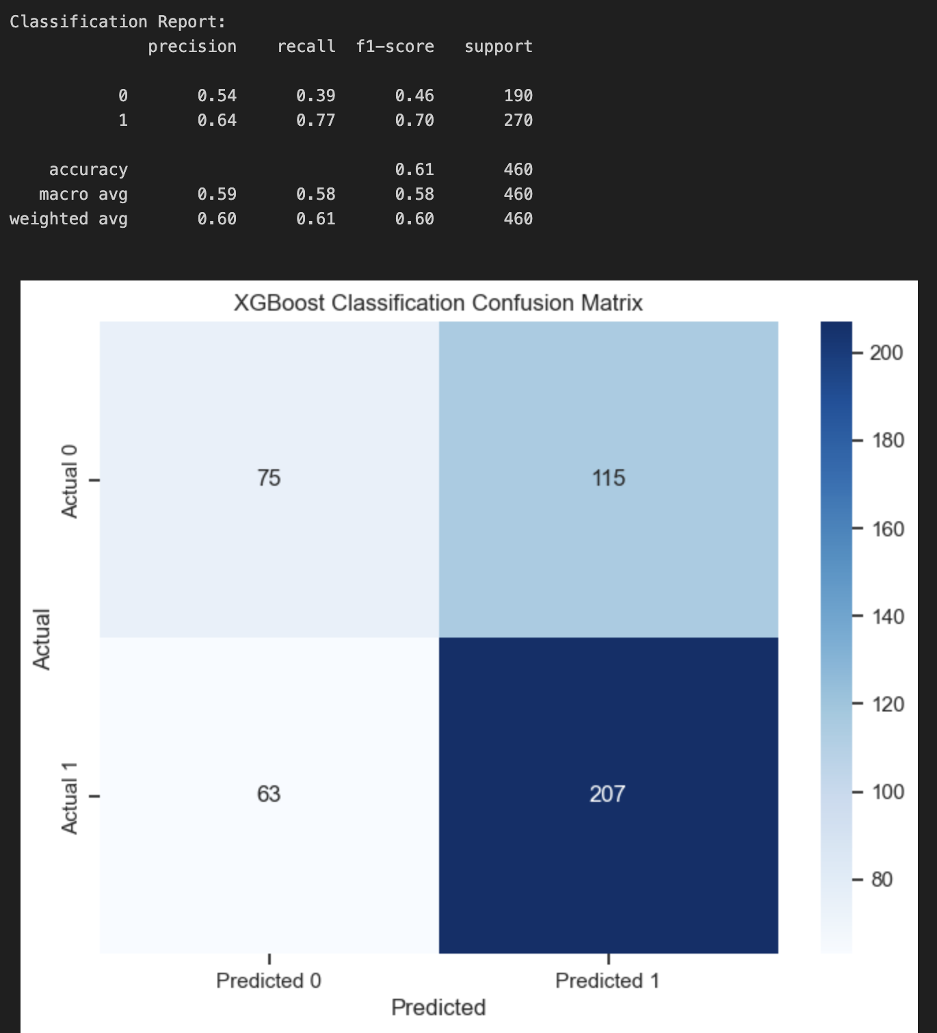
Note: Overall accuracy is only 61% for the initial XGBoost model.

Conclusion
The Analytics Problem Statement is supported because the model is able to accurately predict, with 70% accuracy for all students, on-time semester enrollment in the fall for college after high school graduation. The metric of recall is the most important metric in identifying those students who will enroll identified correctly as enrolling, which has an 88%. This supports the analytics problem statement, to identify the highest rate of eligible mentees who will have the highest likelihood of enrollment.

Model Evaluation
The initial model chosen for the data modeling portion of this project was Binary Logistic Regression, useful for predicting probabilistic outcomes for a binary classification outcome variable. Logistic Regression assumptions were met, which meant that hyperparameters could be tuned, to get the best evaluation out of the Logistic Regression model. Additionally, Support Vector Machines (SVM), XGBoost Random Forest Classifier, and K-Nearest Neighbors models were trained and utilized for predictive classification. After tuning each model, Logistic Regression still had the best overall metrics with a runner up model of XGBoost.
Evaluation Methods
The evaluation model used was k-fold cross-validation with the logistic regression model. After first utilizing a train_test_split within Python, and a test size of 20%, the k-fold cross-validation method was implemented with the same train/test partition of 80/20. K-fold cross-validation is an excellent way to study the variability of a model performance (Li & Ming, 2023). K-Fold cross-validation takes the data, partitions it into a training and testing split, fits the model, and predicts on the fold that is left out of the training set. Then, the process is iterated using the 2nd “fold” of the dataset as the test data, and iteratively continues until all folds defined have been left out of the training set to be used for the test set.
During the modeling phase, to evaluate model performance, the ROC Curve, AUC metric, and the confusion matrix consisting of Recall, Precision, and the F1 Scores were visited along with overall accuracy. Each of the features were also selected using Lasso Regularization at a C = 0.5 to determine the specific features that all contributed statistically significantly to the model. Additionally, because class weights were imbalanced, oversampling the minority class
was implemented to prevent a biased model. The solver used was “liblinear” in the Logistic Regression model. Figure 46 illustrates the trained model for the Logistic Regression with only p-values < 0.05.

Table 11
Logistic Regression Results with Only Significant p-values
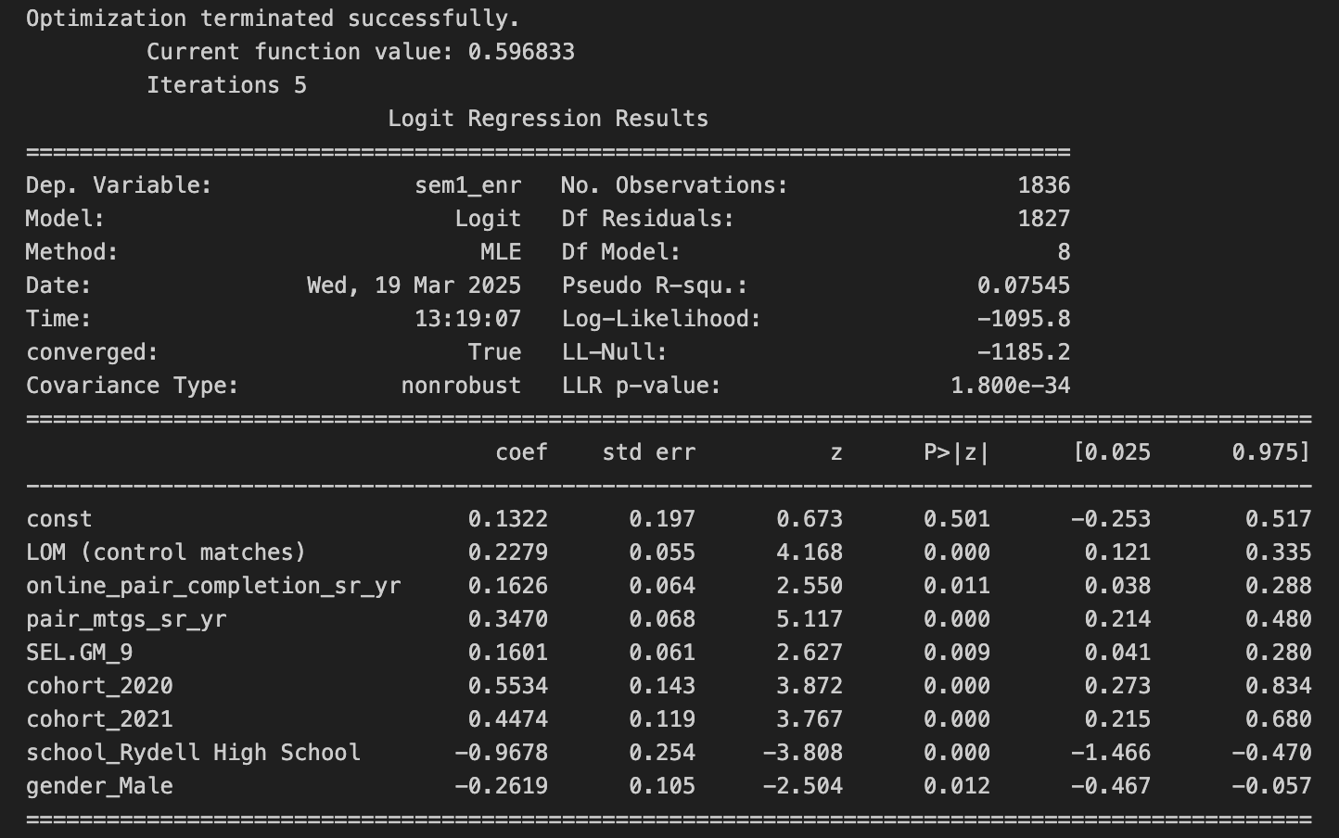

Table 11

Feature Importance and Odds Ratios
Feature | Coefficient | Odds  Ratio | Interpretation
cohort_2020 | 0.5534 | 1.739 | 73.9% increase in odds
cohort_2021 | 0.4474 | 1.564 | 56.4% increase in odds
pair_mtgs_sr_yr | 0.3470 | 1.415 | 41.5% increase in odds
LOM (control matches) | 0.2279 | 1.256 | 25.6% increase in odds
online_pair_completion_sr_yr | 0.1626 | 1.177 | 17.7% increase in odds
SEL.GM_9 | 0.1601 | 1.174 | 17.4% increase in odds
gender_Male | -0.2619 | 0.770 | 23.0% decrease in odds
school_Rydell High School | -0.9678 | 0.380 | 62.0% decrease in odds
2
The corresponding confusion matrix was used to understand model metrics. The tuned hyperparameters are as follows:
- C Value of 0.05
- selected features chosen with only statistically significant features; 'LOM (control matches)', 'online_pair_completion_sr_yr', 'pair_mtgs_sr_yr', 'SEL.GM_9', 'cohort_2020', 'cohort_2021', 'school_Rydell High School', 'gender_Male'
- 5 splits for k-fold cross-validation.
- balanced class weights with oversampling the minority class.

Figure 47
Confusion Matrix for k-fold cross-validation Elastic Nets Regularization

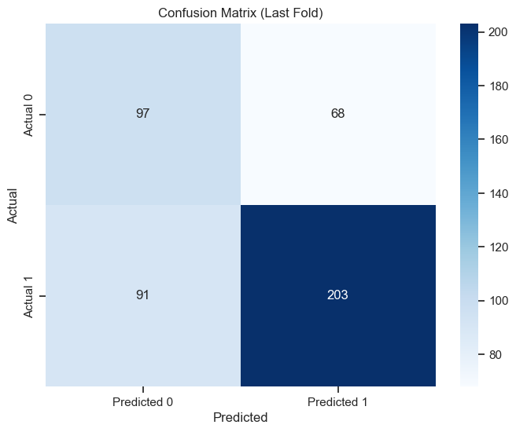

Figure 48
ROC Curve for k-fold cross-validation Elastic Nets Regularization
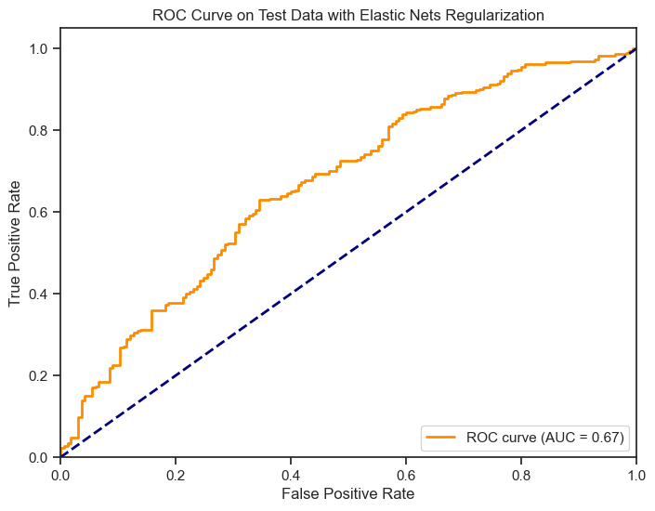
The overall accuracy for this tuned model was 65%, with an f1-score of 72% on class 1 and 55% on class 2. This model had significant advantages by having recall and precision much higher for the underrepresented class, with only statistically significant variables, rather than high precision and recall only on the overrepresented class of sem1_enr = 1. This can be seen in figure 49.

Figure 49
Evaluation Metrics for Logistic Regression Tuned Model
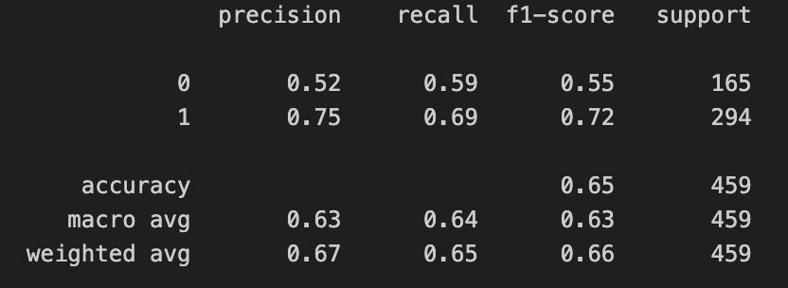
The XGBoost Random Forest Classifier was not able to capture enough of the sem1_enr true negatives, even though accuracy was similar and more of the true positives were captured with the tuned model.The results below show a higher f1-score for the positive class, but lower f1-score for the negative class, in figure 50.

Figure 50
Classification Report and Confusion Matrix for XGBoost RF Classifier
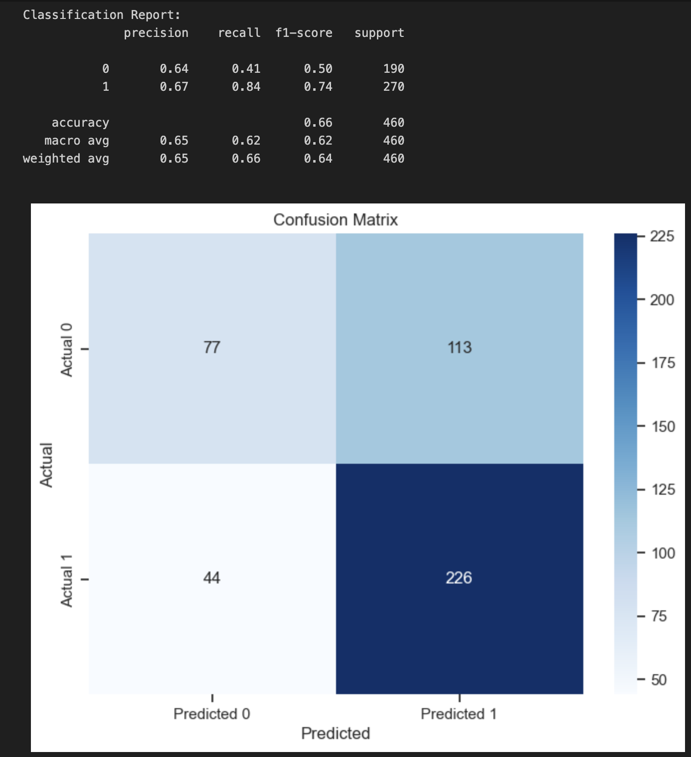
For the comparison of Support Vector Machines and K-Nearest Neighbors, both were tuned and utilized with Confusion Matrices and performance metrics, along with the corresponding ROC Curve. Neither of these two classifiers were able to create the same level of accuracy as Logistic Regression. Therefore, these models were not selected. As an example from the KNN modeling, the K-nearest neighbors k-value was selected at k=19 using the cross_val_score from the sklearn.model_selection library.

Figure 51
Finding the Best k for KNN
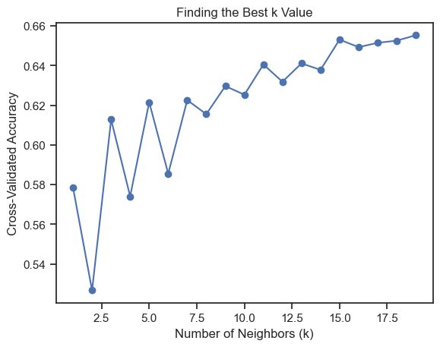
Even with parameter tuning of the KNN algorithm, the model was lacking in predictive performance in comparison with the tuned Logistic Regression model.

Figured 52
Confusion Matrix and Evaluation Metrics for Tuned KNN Model
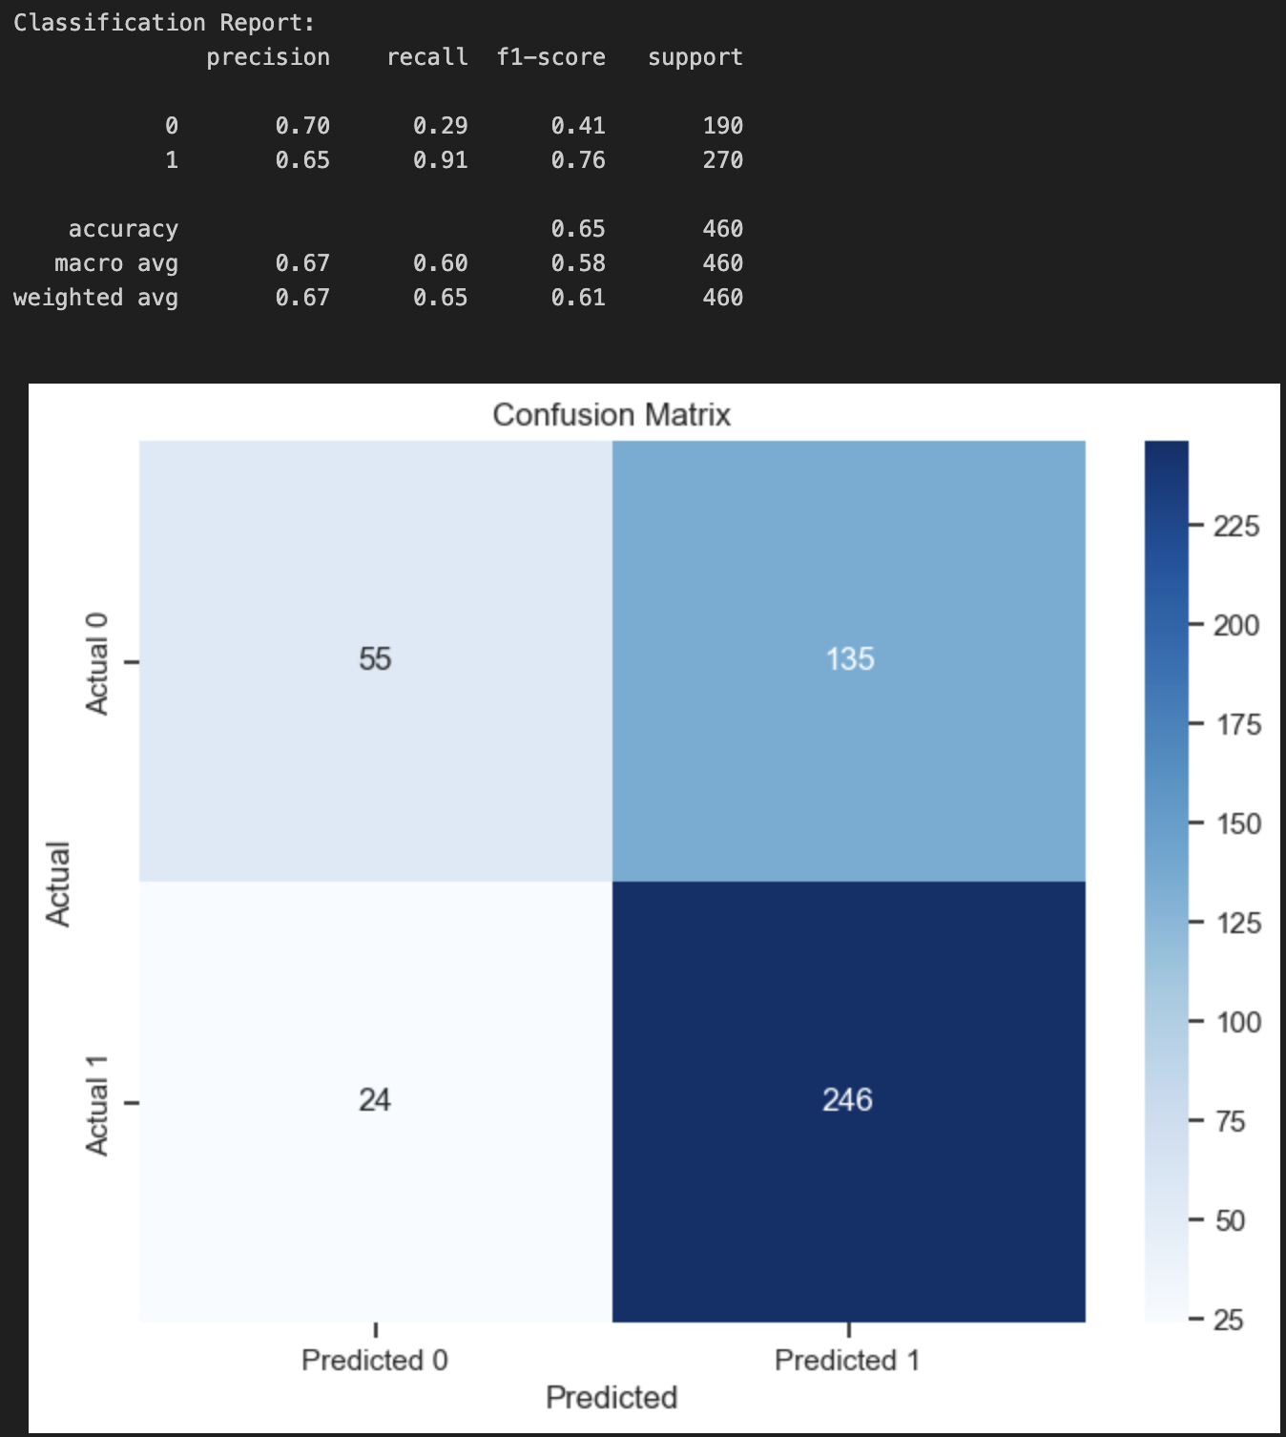
Risk Analysis - Monte Carlo Simulation
Monte Carlo Simulation was chosen as the method for prescriptive analysis on the findings of the tuned and fit logistic regression model using elastic nets regularization and oversampling the minority class. For the Monte Carlo Simulation, the problem was defined as: “what are the effects of changing statistically significant input variables on sem1_enr average overall enrollment rates? For the input Variables and their Probability Distributions:
- LOM (control matches): Normal
- online_pair_completion_sr_yr: Normal
- pair_mtgs_sr_yr: Normal
- SEL.GM_9: Normal
- cohort_2020: Binomial
- cohort_2021: Binomial
- school_Rydell High School: Binomial
- gender_male: Binomial
Output Variable and its Probability Distribution:
- Sem1_enr: Binomial
The Monte Carlo simulation ran 2766 times using each selected standardized feature to ensure that feature coefficients were meaningful in creating outcomes. Changing the LOM (control matches) and the online_pair_completion_sr_yr variables to assess risk of Average enrollment were explored. When LOM (control matches) showed 69% of the maximum value, the on-time semester enrollment average dropped down to 57.2%. A few other key metrics were explored to understand and assess the risk of LOM (control matches) feature’s contribution at various levels:
- At 50%, the average dropped to 56%.
- At 100%, the average jumped up to 59.3%.
- At 0% , the average was lowest at 52.6%

Assess Results With Respect to Business Success Criteria
The results of the predictive modeling and prescriptive analysis portions of the CRISP-DM process during model evaluation showed some key insights. Firstly, Rydell High School had an abnormally and strong statistically significant negative impact on overall Fall semester on-time enrollment, shown by a distribution of the sem1_enr outcome variable in Figure 53.

Figure 53
Distribution of Rydell High School Sem1_enr
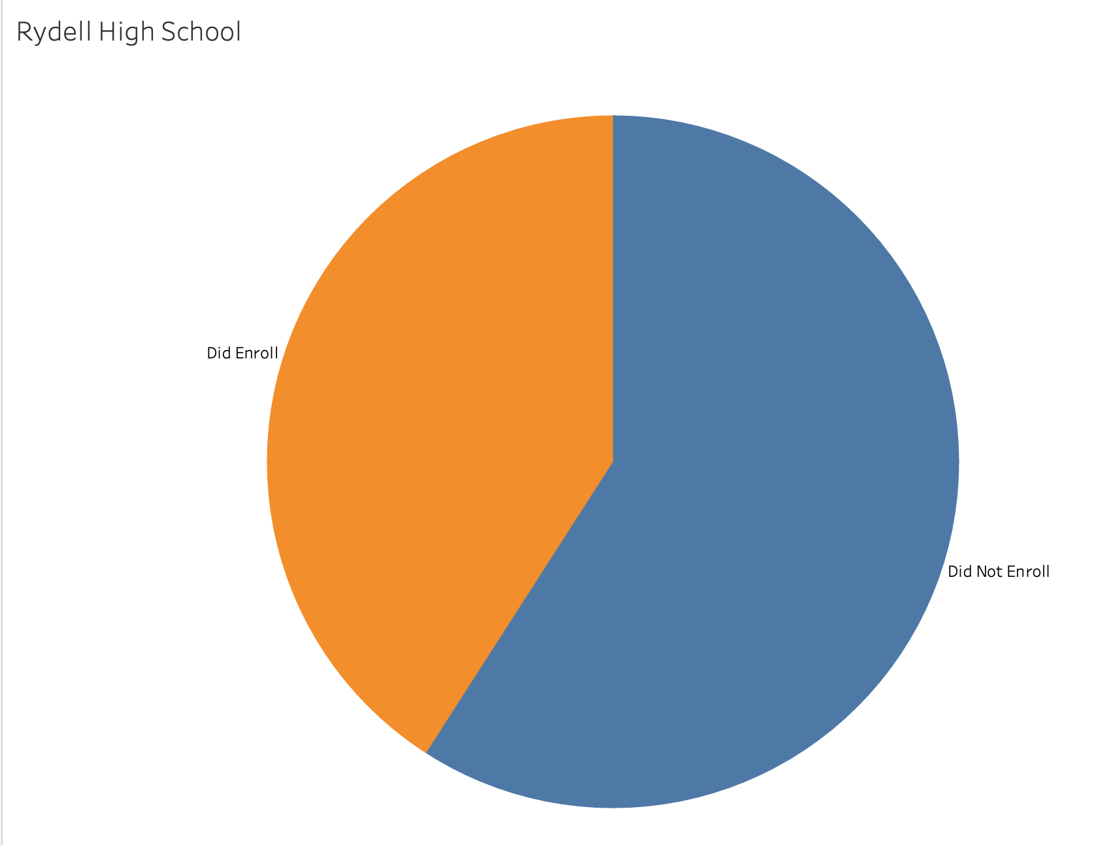
Rydell High School also was included in the Monte Carlo Simulation, showing that a change just in this school would have a major impact on results, from 55% to 66% in on-time semester 1 enrollment, as shown below in Figure 54.

Figure 54
Python code for simulation of Rydell High School
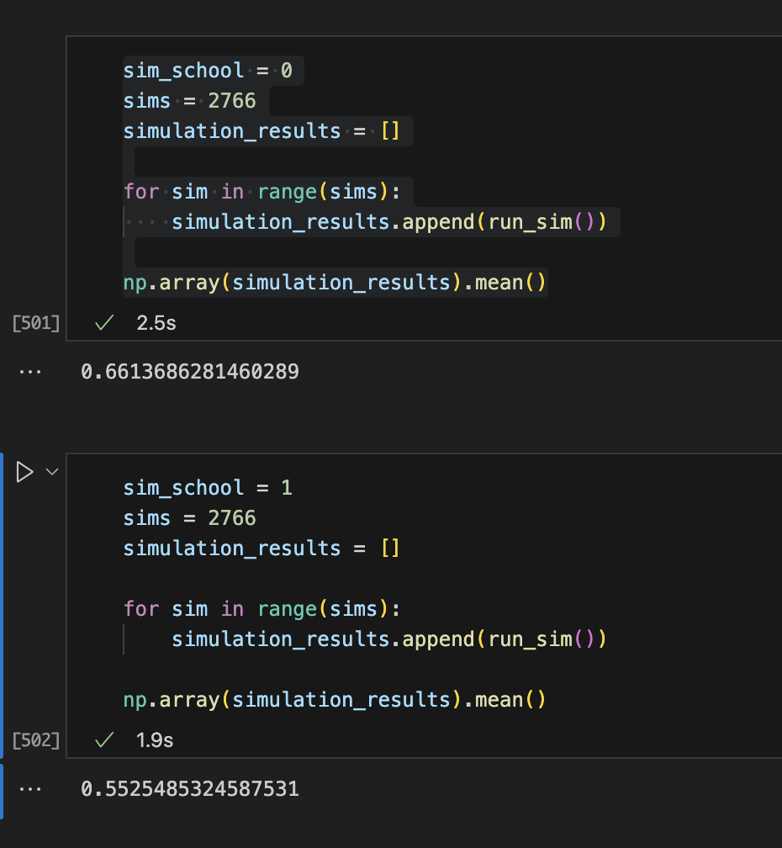
Additionally, during the modeling phase, the 2020 and 2021 cohort populations of students had the most significant impacts for on–time semester enrollment.

Figure 55
Cohorts 2020 and 2021 - Rates of Enrollment
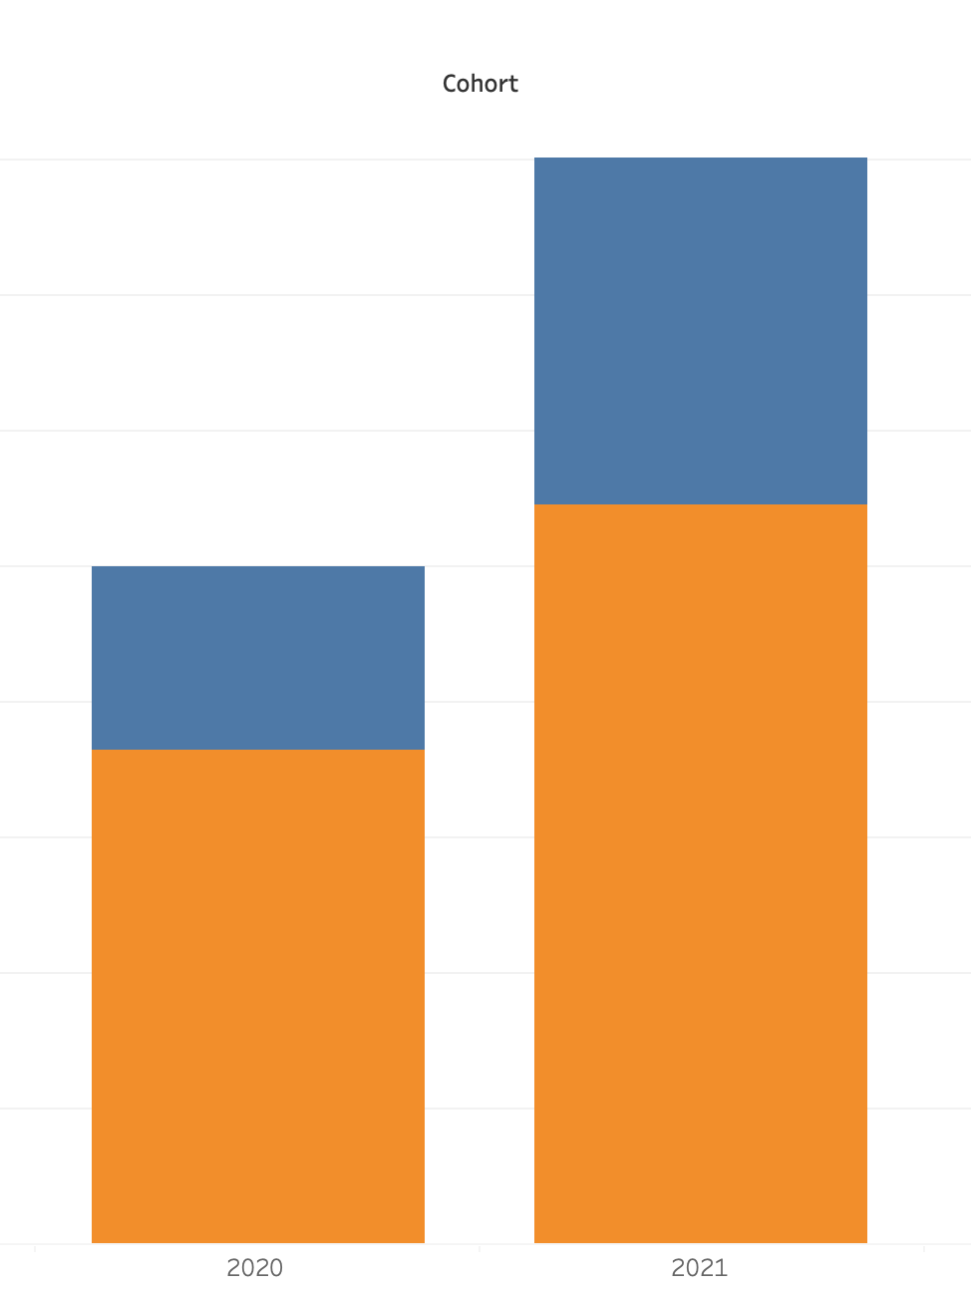
Some insights gained here is that Cohort 2020, with its contribution of a coefficient of 0.5534, shows positive contribution towards the predictive model in increasing accuracy of predictions. Some additional challenges to be discussed further would include what specifically separated these two cohorts of students both from one another and from the other cohorts, running new models and predictions based solely on each cohort in the EDA phase of the data mining process.
One of the ways the model is deficient here includes the Monte Carlo Simulation needing further development. The Monte Carlo simulation did show how a few risks would affect average online enrollment. For example, the online_pair_completion_sr_yr variable at 0% yielded a 64.9% enrollment rate, whereas at 100% online_pair_completion_sr_yr, the enrollment rate jumped up to 69.5%. Interestingly, when LOM (control matches) was changed to 60%, and online_pair_completion_sr_yr was moved 100%, the average on-time enrollment rate went to 66%.

Figure 56
Python Monte Carlo Simulation: 0% to 100% online_pair_completion_sr_yr
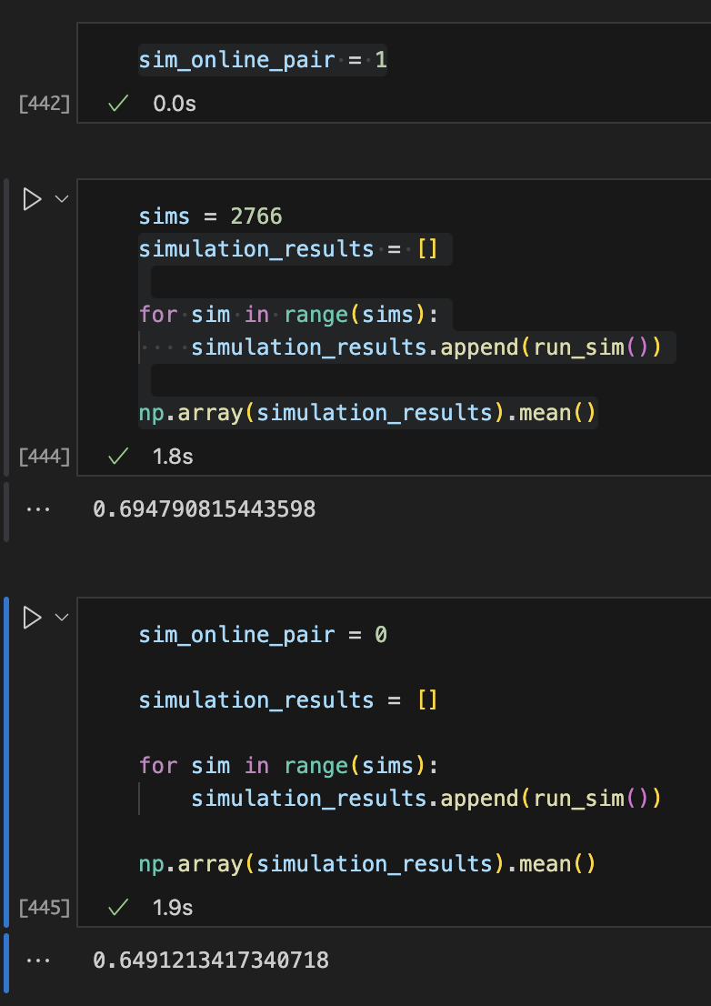

Conclusion
The model and Monte Carlo Simulation both support the Business Problem Statement and Analytics Problem Statement by providing evidence and tools to create predictions and solutions to increase sem1_enr rates with risk analysis also available. The largest contributors in the evaluation, tuned, and fitted Logistic Regression model along with the Monte Carlo simulation are supported by metrics such as only statistically significant features measured with p-values, no VIF above 5, Accuracy, f-1 scores, precision, recall, confusion matrices, balanced classes, model selection, ROC Curves (AUC scores), and simulated scenarios to prescribe outcomes to the business.

External Model Verification and Calibration
The external model verification process for the current Binary Classification Logistic Regression Calibrated model includes understanding the acceptable thresholds and expected levels of predictive performance for high school graduates enrolling on-time into college the fall semester after graduation. External validation requires that the data be tested independently from the group using independent test data, focused on design, sample size reporting, and assessment of predictive performance (Collins et al., 2014). Additionally, already existing predictive models should be compared to the currently used model for each project. The literature review should also explain the range of continuous variables, to avoid extrapolation (Collins et al., 2014). For this data mining project, k-fold cross validation, external validation, and expert validation were all utilized in order to confirm alignment with findings in other similar studies. In particular, finding the online completion of the mentorship pairings, number of meetings, and cohorts were expected findings.

Literature Review
Mentorship as a discipline is meant to be a development strategy for youth to find their path to young adulthood by partnering with more experienced adults providing guidance, support, and encouragement (Mentor, n.d.). With the Social-Emotional Learning Outcome that statistically contributed most to the model, SEL.GM_9 which is described as “planning for what job I want when I’m older” positively and significantly contributed to the over sem1_enr outcome on positive immediate college enrollment rate. This logically makes sense, considering planning for specific jobs and careers give direction, purpose, and motivation for enrolling not just in college, but specific colleges. Vision leads direction. Xing et al., (2019), found in a Logistic Regression Data Mining study similar to this one provided the means of discovering socio-economic status as a statistically significant predictor across the United States as the only meaningful metric. This is one of the external sources that is reviewed.
According to Xing et al., (2019), social-emotional learning outcomes along with academic success, career proficiencies, and problem-solving were the main definitions for which assessing college readiness and enrollment is founded upon. The authors explain how a Multinomial Logistic Regression model created a predictive model that only saw socioeconomic status as a meaningful predictor of outcomes. One issue is that many programs, while designed for a specific group of students, fail to address all students collectively. Collectively, students in the United States enroll in college immediately after High School at a 62% rate (National Center for Education Statistics, 2024). Interestingly, however, the enrollment rates between 2021 and 2022 were not statistically significantly different. This is in contrast to the model developed in this study, which shows that cohorts 2020 and 2021 both statistically showed a difference and effect on the Logistic Regression model as significant contributors. Because of this challenge, the study sought to look at demographics, activities, and specific readiness the student had across the United States. The largest finding that validates the model I created was that after thorough data analysis, the finds that “providing high-quality college and career exploration and counseling options, such as reviewing options after high school with the student, offering direct information about college and careers, and extend exposure to college and career environment are likely to help students navigate transitions after high school” (Xing et al., 2019).

Calibration
The calibration methodology included using the Logistic Regression Model and XGBoost for calibrating the model in accordance with expected probabilistic findings. According to Brownlee (2019), the predicted probabilities in a model should match the expected probabilities, and can be diagnosed using a reliability diagram. This is for calibrating a specific model quantitatively. Logistic Regression models are calibrated by the nature of the modeling technique (Brownless, 2019), so I took the approach of applying calibration to the XGBoost Random Forest Binary Classification model.
The XGBoost Classifier was not calibrated, biased towards the positive class of prediction sem1_enr = 1. Figures 57 and 58 below show the changes between an non-calibrated model performance versus the calibrated model performance.

Figure 57
Non-calibrated XGBoost RF Classifier Over-Forecasing Probability
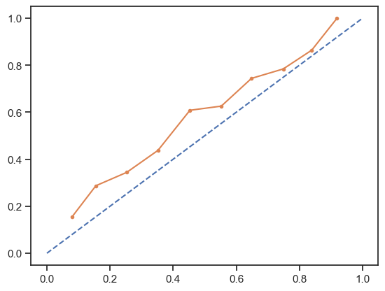

Figure 58
Calibrated XGBoost RF Classifier with Isotonic Calibration
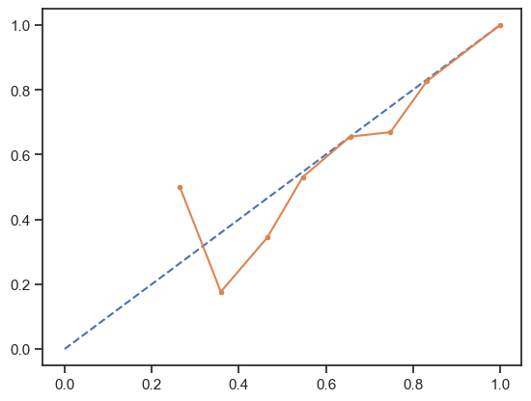
Once the XGBoost Random Forest model was calibrated, the predictions on the test date increased in overall accuracy by about 2%. The orange line represents the calibrated model’s alignment with expected probabilities.

Figure 59
Confusion Matrix & Classification: XGBRF Calibrated Model on Test Data
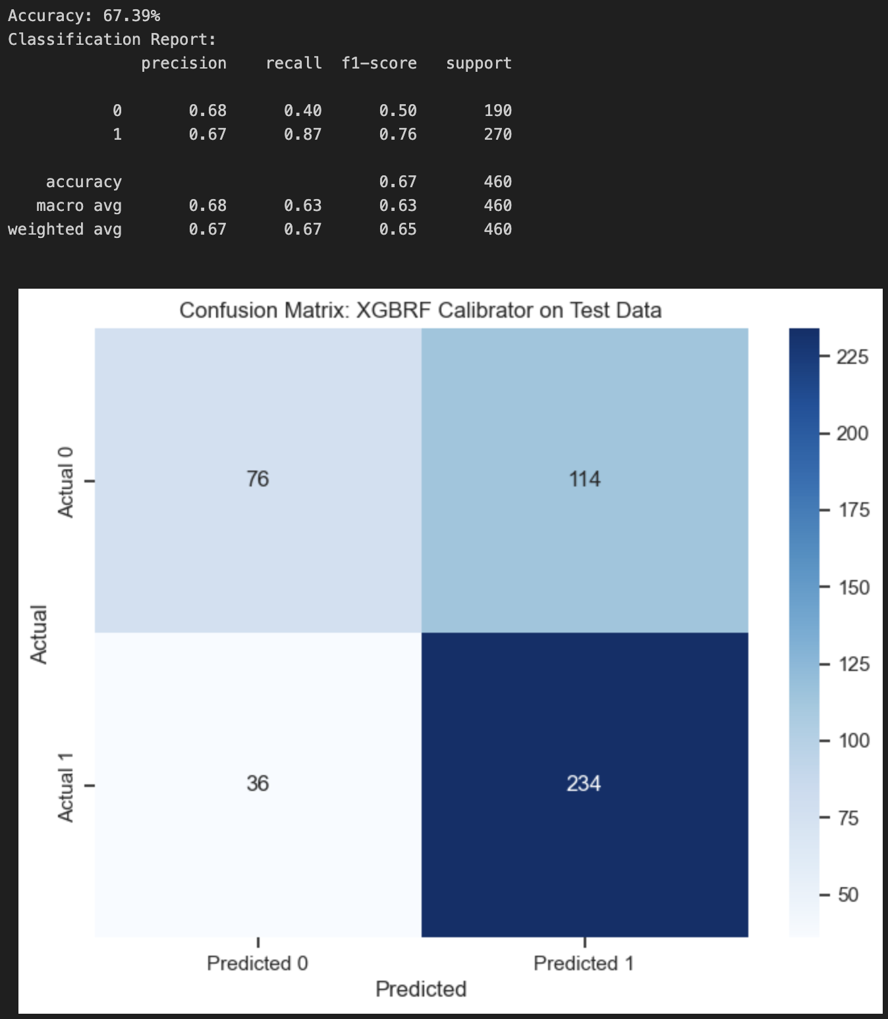
Additionally, once the model was calibrated fully, the entire dataset was used to retrain the model and create predictions based on the entire dataset. Because there was much more data, the overall predictive power of the model significantly increased to 74.6% accuracy, while also maintaining high F1 scores for both the sem1_enr positive and negative classes, as seen below in figure 60.

Figure 60
Isotonic Calibration XGBoost Random Forest Classification on All Data
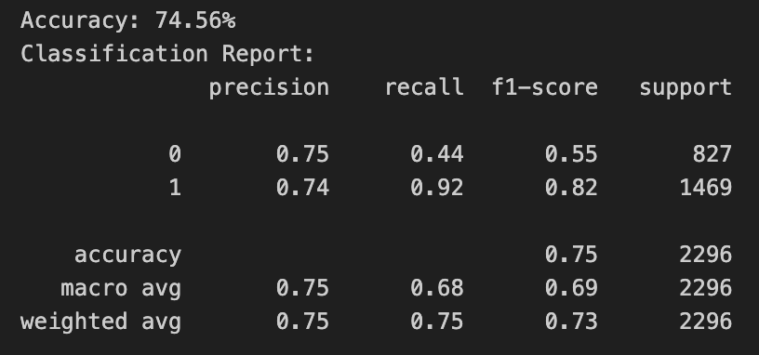

Figure 61
Isotonic Calibration XGBoost Random Forest Classification ROC Curve
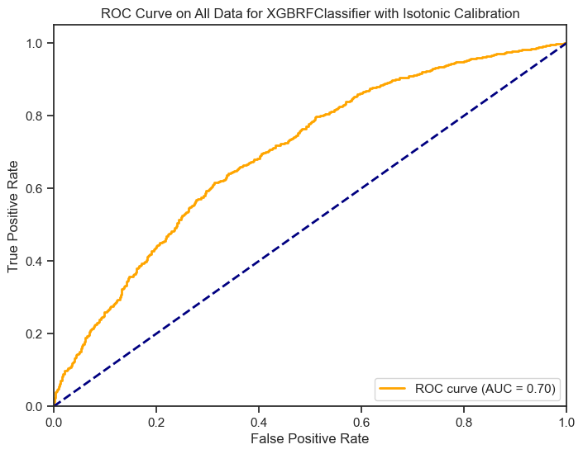

Figure 62
Confusion Matrix: All Data XGBoost RF Classifier with Isotonic Calibration
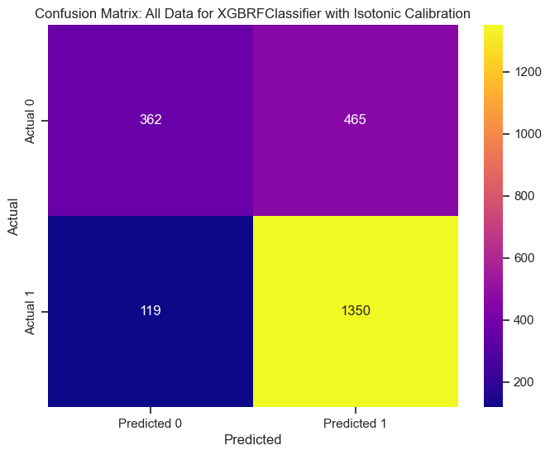
External Validation Case Study
The original model utilized k-fold cross validation with oversampling the minority class to validate the accuracy and results for prediction, prior to being trained on the full dataset. During external validation, the dataset “college.csv” from Kaggle for College Attendance classification served for validation. The same Logistic Regression model with oversampling the minority class, elastic nets, and hyperparameter tuning was used for predicting based on the new College Attendance Dataset. This data was gathered from the US Department of Education and made available on Kaggle.

Figure 63
College Attendance Dataset
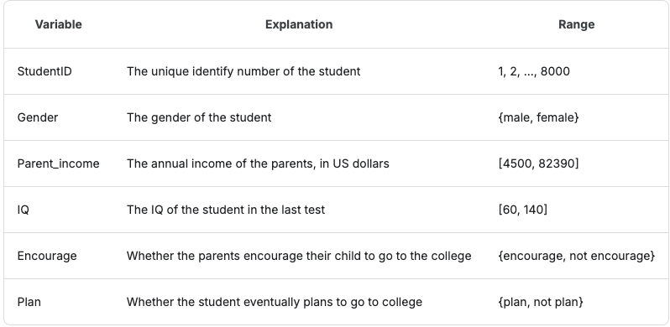
This dataset was chosen in alignment with a similar outcome variable (immediate college enrollment) along with similar strong predictors of enrollment as the explanatory variables (gender, encouragement from parents) because of the similarity to the “planning for the job I want when I am older” with mentorship social-emotional learning outcomes in the original dataset.
The dataset background included data distributions showing normal distributions for numerical continuous data (Parent_income, IQ) but imbalance within the binary integer data and binary categorical data (Gender, Encourage, Plan).

Figure 64
Data Distributions of all College Dataset Variables and Descriptive Statistics

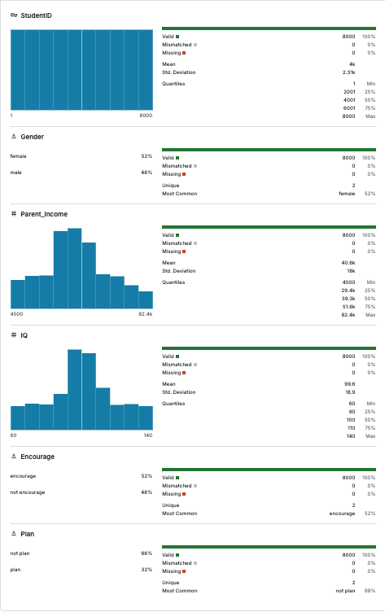

Figure 65
Compact Data Distribution of Variables
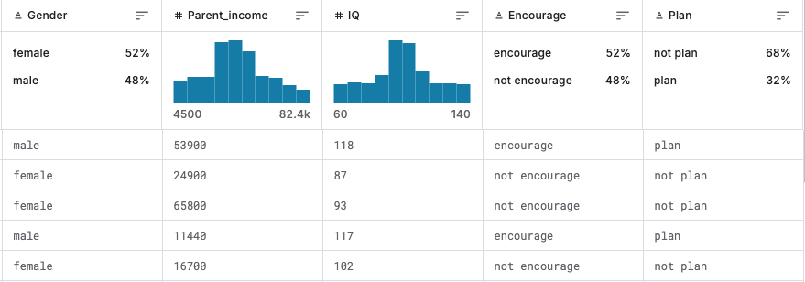
In this external validation study, similar steps were utilized for preparing, cleaning, feature engineering, and feature selection (using VIF scores and elastic nets regularization) prior to creating the predictive model. Data distributions were also similar to the original dataset, showing that oversampling the minority class created class balance prior to running through the prediction of the trained Logistic Regression model. Some findings included that the model actually predicted higher accuracy (79.92%) overall than it did on the mentorship data.

Figure 66
Classification Report on College Dataset
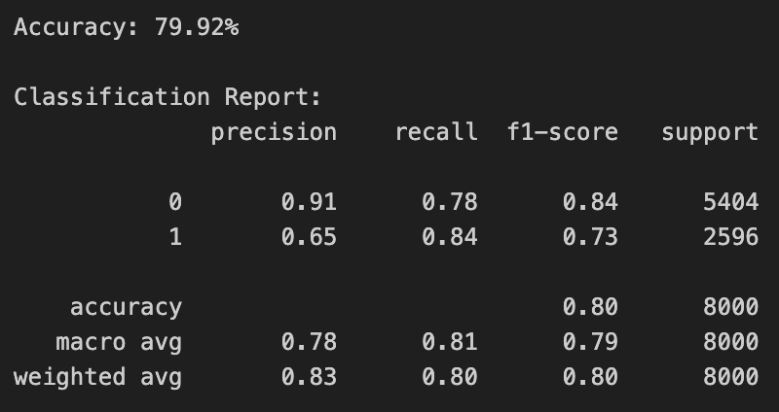
The classification report shows an overall precision and recall harmonic mean, F1-score for the “not plan” outcome variable at 84%, with high precision at 91%. This is advantageous in understanding how to target these particular students in classification tasks because they will need additional encouragement, support, mentorship, and other areas to successfully enroll in college immediately after high school graduation.

Figure 67
ROC Curve for College Enrollment Dataset
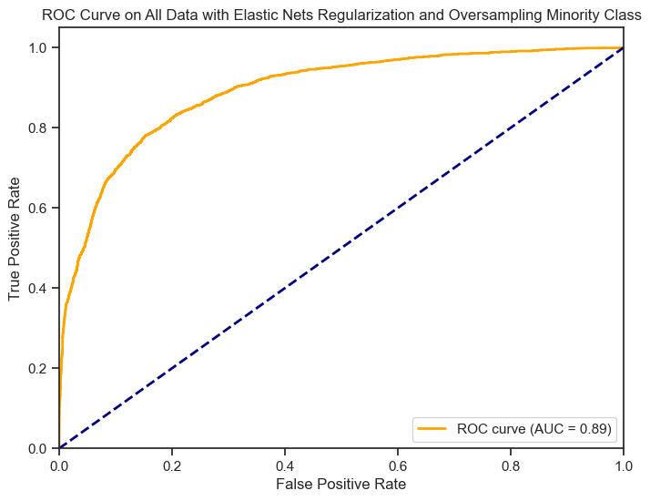
With an AUC score of 0.89, the model is very strongly predictive of the correct binary class.

Figure 68
Confusion Matrix for College Enrollment Dataset
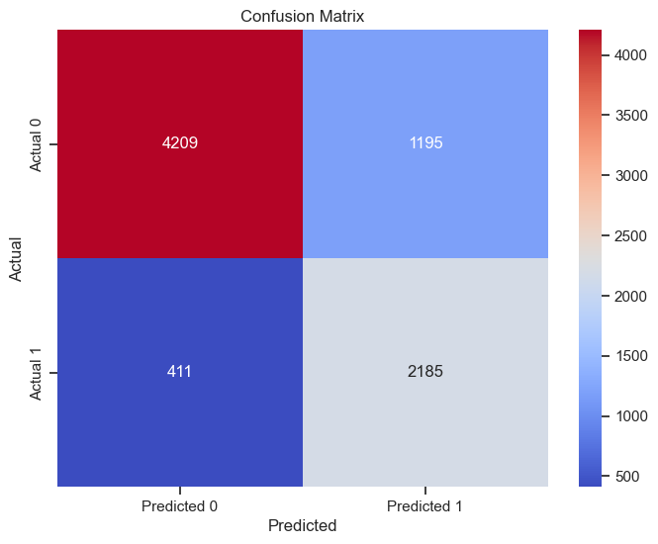
In the confusion matrix, more true negatives and true positives were identified, especially with true negatives. This is a strong predictive model because the goal of the model is to understand and identify those students who need additional support, which are the “true negative” class in this model. The precision of 0.91 and recall of 0.78 strongly support with evidence the predictive power of this binary classification Logistic Regression model.

Future Recommendations
Overall, after conducting external model validation and literature review, the findings were consistent with those findings in the field, along with providing a fresh perspective on specific social-emotional learning outcomes through mentorship programs providing unique and positive predictors for future immediate college enrollment success. However, the model would need to have a couple of small adjustments. Mainly, because Mentor Contact data was made available, this data would be utilized for further analysis to see if any of these were confounding variables, or had statistical significance between mentor and mentee pairings on immediate college enrollment.
For strengths of the project, the Logistic Regression Model predicted with high accuracy, recall, precision, and F1 Scores with a reduced dimension model to identify students who would be at risk the most of not enrolling into college immediately. Calculating VIF Scores and combining this process for feature selection with elastic nets regularization and GridSearchCV allowed the model to create predictions using only the variables that were not exhibiting multicollinearity as well as those that contributed statistical significance. The model performed well on data from the external validation study. The data exploration and cleaning process provided a plethora of insight into the population of students. Additionally, using these cohorts from 4 different years, 3 different locations, and with 4 separate datasets integrated, some meaningful and realistic actionable insights were gathered. These actionable insights included increasing mentorship programs at Rydell High School for male students, specifically focused on LOM Control Matches, online pair completion, number of pair meetings, and centered on helping students plan ahead for the job that they want. This was achieved by using Monte Carlo Simulation. The data mining results meet the business objective and provide specific insight into strengths and predictors for future mentorship program planning.
The simulation model using Monte Carlo Simulation was difficult to interpret and also challenging to implement. In the future, this will either need to be revisited using a different understanding of the data set, or be used where the results can be explained with much more interpretability. The data visualizations in the Python Notebook using automated univariate chart creation were not as useful or interpretable as when used with Tableau to generate the same charts. In Tableau, the dashboard was both rushed and not clearly connected to a live datastream. Additionally, the dashboard was not adjusted to be optimized for color, structure, or for mobile reports. Using Python, crossing between the statsmodels API and the scikit-learn APIs were not helpful, as one or the other should be chosen rather than trying to blend both of them together. This created confusion. For example, statsmodel API can be used to print out the logistic regression trained model results along with their associated p-values. However, scikit-learn cannot print these results, reducing interpretability of specific explanatory variables. Not writing and defining functions did not work well. This led to multiple times re-writing functions and recycling code (copy/paste) rather than simply automated recursive process using loops and other iterations.
One of the specific ways to improve this project is simply Including additional data from the data collection phase of the CRISP-DM process. Additionally, crafting a better automated univariate charts Python script would help the model be robust and repeatable for results. Lastly, spending more time creating the Tableau Dashboard, including breaking the dashboard down into more than one page, if there are many items that are added to the dashboard. The future recommendation utilized would also include data collection methods; the SEL outcomes rated on a scale from 1 to 4 is too restrictive, and may be better accommodated by extending the scale either 1 to 5 or 1 to 10 to increase diversity in answers.

Model Deployment and Model Life Cycle
Executive Summary
In order to create deployment, understanding the purpose of deployment is paramount. IBM explains deployment as the process of utilizing findings to make improvements within your organization (2018). The purpose of this deployment is to ensure that all involved stakeholders such as mentors, managers, program directors, and program partners can each have a decision support tool to enhance their domain area expertise, to make decisions using these insights into mentee/student immediate college enrollment. The predictive models have been trained, significance variables are identified, and a dashboard through Tableau and app through Gradio will be provided to stakeholders, along with a training and continuous improvement/continuous development plan.

Improvement Plan
The retrospective showed that the data integration, cleaning, and data exploration process yielded strong findings and actionable insights, such as Rydell High School’s statistically significant impact contributing to not enrolling immediately into college upon high school graduation and the SEL Outcome of “planning for what job I want when I’m older” making the most impact in determining a positive outcome for sem1_enr.
As the deployment phase occurred, one thing that required improvement was the data analysis between cohorts, schools, and gender. The data can be broken down to look at multiple different samples of the populations directly, rather than as a whole with the larger sample including the students who were included in the project. Additionally, this could mean discovering why certain High Schools had such higher enrollment rates in comparison to other High Schools, the SEL Outcomes associated, and any demographic information that would impact enrollment specific to each school or cohort. Possible new risks to these data mining projects could include biased information, not enough data, or time wasted discovering no insightful findings.
The scope change for the deployment phase in the future would also include more input from relevant stakeholders, ensuring that the database data collection methods for mentor survey data and mentor communication data are collected for all mentors, and that more models could be testing. Mentor communication only represented 382 of the mentor/mentee pairs (10%), but if the scope changed to ensure all mentor/mentee pair communication was tracked, new data mining projects could be discovered such as time series forecasting models and additional insight into SEL outcomes along with long-term learning outcomes such as immediate college enrollment.

Deployment Strategy
Deployment of the XGBoost and Logistic Regression trained models with the Gradio App, hosted on HuggingFace, trained with on the job training and continuous peer feedback through informal and formal loops will have a perceived cost of time and resources for staff trainings and staff feedback time, but will potentially result in an increase of immediate college enrollment by 16%, $757,500 in potential additional funding, and the intangible benefits of increased donor involvement with increased social justice improvement in areas of low socioeconomic status and minority groups. Relevant stakeholders will have access to a deployed Tableau dashboard for further exploration into their specific regions, cohorts, curriculum, and speciality areas.

Milestones, Training, Cost/Benefit, and Risks
The Deployment phase first starts with planning, then progresses into development, deployment, and then post-deployment (Restackio, 2025). For the requirements stage, understanding stakeholder needs is first - which is determining the factors influencing long-term learning outcomes, primarily dominated by sem1_enr having a positive outcome. The identified stakeholders are the program sponsors responsible for designing the mentorship program in addition to the curriculum designers, marketing teams, and IT department matching mentor and mentee pairs. For development, the process has already been completed through training the ML Model. In pre-deployment, the model needed to be checked to see if it performs on real-world data as expected, which is validated through k-fold cross validation and external validation. After this is completed, the plan is the model will be containerized in a Gradio format, then deployed for business usage. Kubernetes is an alternative deployment method using a Docker container and REST API interface. Setting up monitoring of the deployment is also crucial, for detecting any post-deployment issues. The model will be deployed over a one-month period, creating a feedback loop after 2 weeks, 4 weeks, 3 months, and then 6 months. The feedback loop will provide continuous feedback, improvement, and development of the model.
The recommended training methods will focus on daily work incorporation, with continuous learning. Essentially, even if the model deployment is not fully understood, it will be integrated immediately with teams to work with their peers in sessions on using it to predict on potential students. The idea here is that supporting these stakeholders with the analytics solution enhances and supports making decisions on which students to focus on for mentorship. According to Yu (2023), continuous applied learning benefits teams more than episodic theoretical learning, meaning that, for this particular implementation, a 30 minute in-person session of utilizing the analytics solution in a focused learning session, along with providing peer-to-peer feedback in a remote or on site environment will assist with implementation of the solution.
Knowledge sharing with the team is another excellent training method. This allows peers who are excellent with tools or domain areas to share their area of expertise, while also implementing the work on a day to day basis (Yu, 2023).
Concretely, this will broken down into training into 5 parts:
- 15 minute meeting teaching, explaining, and demonstrating the purpose, use case, and workings of the analytics solution.
- Pre-recorded video to support learning.
- 15 minute workshop after the training to practice putting the solution into action.
- Ongoing feedback through survey submissions for continuous improvement.
- Follow up training and demonstrations, along with specific questions offered as necessary. On-the-job training as necessary to support continuous learning or onboarding new hires.
Because costs with this project are all qualitative (those who enroll vs. those who don’t), and the program is using donor money, the impact is for every student who does enroll, increased support and funding occurs, leading to increased donors. This in turn allows iMentor more resources to conduct future mentorship pairings. With a total budget of $22,272,149 and 116 donors, the “average” donor donates $192,001, with $1M+ and a minimum of $2500 as the range of donations. This means that if one additional donor is gained, at minimum, the donation will be $2500. For each 3 donors, at minimum, a new Mentee/Mentor pair could be supported. However, with the average donor, 32 additional mentee/mentor pairs could be supported. The main costs involved with the analytics solution are simply time, training, and scalable usage of the deployment through Gradio on HuggingFace, which is currently free to use in a small capacity.
Some additional benefits of the project which are intangible benefits that outweigh the very small risks, for increased trust and support in iMentor as a non-profit to benefit schools, students, and as a place for increased mentorship, there is:
- Potential to receive more donors/sponsors.
- Increased visibility of iMentor students represented in colleges.
- Increased number of minority groups enrolling in college, decreasing racial gaps.
- Increased number of mentees/students from a low socioeconomic status who have the ability to enroll in college by receiving mentorship, specifically from schools where student enrollment is low.

Recommendations and Conclusions
Recommendations for Practice
The business problem and analytics problem revealed that race/ethnicity had no statistical significance in the predictive modeling of determining immediate college enrollment, but did have statistical differences amongst racial groups. Additionally, some specific SEL outcomes that were highly focused upon were not as relevant, while only one SEL outcome (“planning for the job I want to have”) had statistical significance. The recommendations for business action includes the following:
- Focus on Rydell High School Mentor/Mentee Pairs. Students from Rydell High School had 62% decrease in the odds of enrollment.
- Increase the amount of curriculum focused on the SEL Outcome “planning for the job I want to have”
- Increase the support and number of meetings male mentee students have with their mentorship; being Male had a 23% decrease in the odds of enrollment as compared to Female students.
- Deploy a Tableau dashboard to give access to stakeholders for understanding their specific data and sample of the population of students.
- Deploy the Gradio app with the predictive model to support identifying and providing additional support to mentees. For example, if a mentee has a low number of LOM (control matches), this can indicate to the IT team there may be an issue with the student input data, or manual intervention may be required by domain area experts.
Recommendations for Future Research
The recommendations for future research springboard out of the initial data mining project into discovering, especially, mentor/mentee communication trends. Additionally, written survey data for Natural Language Processing methods will include more detailed insight, qualitatively, for mentees on what will assist them with increased immediate college enrollment. Based on the literature found, that only 64% of students nationwide have immediate college enrollment, but that mentorship significantly increases the ability to provide positive impact, additional expansion of qualitative data (such as a larger scale for each SEL outcome) will support future research initiatives.

References
Bobbitt, Z. (2020, October 13). The 6 assumptions of logistic regression (with examples). Statology. https://www.statology.org/assumptions-of-logistic-regression/
Brownlee, J. (2023, December 5). Logistic regression for machine learning. MachineLearningMastery.com. https://machinelearningmastery.com/logistic-regression-for-machine-learning/
Brownlee, J. (2019, September 24). How and when to use a calibrated classification model with scikit-learn. MachineLearningMastery.com. https://machinelearningmastery.com/calibrated-classification-model-in-scikit-learn/
Ellison, T. & Deeke, J. (2021). Data science exploration. University of Illinois
Urbana-Champaign. https://exploration.stat.illinois.edu/about/
Frost, J. (2024, April 17). Simpsons Paradox explained. Statistics by Jim. https://statisticsbyjim.com/basics/simpsons-paradox.
Frost, J. (2018, November 12). When do you need to standardize the variables in a regression model? Statistics by Jim. https://statisticsbyjim.com/regression/standardize-variables-regression/
GeeksforGeeks. (2025, January 2). Detecting multicollinearity with VIF Python. GeeksforGeeks. https://www.geeksforgeeks.org/detecting-multicollinearity-with-vif-python/
Gouvea, A. (2021). The CRISP-DM methodology [PDF]. Github.
https://github.com/almirgouvea/The-Crisp-DM-Methodology/tree/main
Grand Canyon University. (n.d.). History & campus growth.
https://www.gcu.edu/why-gcu/history-of-gcu
Härting, R., & Sprengel, A. (2019). Cost-benefit considerations for data analytics - An SME-oriented framework enhanced by a management perspective and the process of idea generation. Procedia Computer Science, 159, 1537–1546. https://doi.org/10.1016/j.procs.2019.09.324
IBM. (2018). IBM SPSS modeler CRISP-DM guide.
https://www.ibm.com/docs/it/SS3RA7_18.3.0/pdf/ModelerCRISPDM.pdf
iMentor (2025, March 27). Our model for volunteer mentorship for high school students. https://imentor.org/who-we-are/model
Jaggia, S., Kelly, A., Lertwachara, K., & Chen, L. (2023). Business analytics:
Communicating with numbers (2nd ed.). McGraw-Hill Higher Education (US).
Kervizic, J. (2018, April 29). Overview of the different approaches to putting machine learning (ML) models in production. Medium. https://medium.com/analytics-and-data/overview-of-the-different-approaches-to-putting-machinelearning-ml-models-in-production-c699b34abf86
Knox, L. (2023, October 23). Assessing college readiness for the pandemic generation. Inside Higher Ed. https://www.insidehighered.com/news/admissions/traditional-age/2023/10/23/assessing-college-readiness-pandemic-generation
Li, H., & Ming, L. (2023, April 18). Practitioner’s guide to data science.
https://scientistcafe.com/ids/
Lubovsky, D. (2020). Selection of educational routes by high school and college graduates: A positive psychology approach. RUDN Journal of Psychology and Pedagogics, 17(4), 656–670. https://doi-org.lopes.idm.oclc.org/10.22363/2313-1683-2020-17-4-656-670
Mentor (n.d.). Mentoring: An investment in positive youth outcomes.
https://teammates.org/wp-content/uploads/2016/05/What-is-Youth-Mentoring.pdf
National Center for Education Statistics. (2024). Immediate college enrollment rate. Condition of
Education. U.S. Department of Education, Institute of Education Sciences.
https://nces.ed.gov/programs/coe/indicator/cpa.
National Center for Education Statistics. (2024). Immediate college enrollment rate (51).
Condition of Education. US Department of Education.
https://nces.ed.gov/fastfacts/display.asp?id=51
Nguyen, M. (2025). A guide on data analysis. Bookdown.
https://bookdown.org/mike/data_analysis/imputation-missing-data.html#missing-at-rand
m-mar
Norton, H. J., & Divine, G. (2015). Simpson’s Paradox . . . and how to avoid it. Significance, 12(4), 40–43. https://doi.org/10.1111/j.1740-9713.2015.00844.x
Pigato, J. (2014, August 12). Transforming data with intelligence. TDWI.
https://tdwi.org/Articles/2014/08/12/Predictive-Analytics-Collaboration.aspx?Page=1
Restackio (17 March, 2025). Model deployment timeline overview. https://www.restack.io/p/model-deployment-answer-timeline-cat-ai
Soland, J. (2013). Predicting High School Graduation and College Enrollment: Comparing Early
Warning Indicator Data and Teacher Intuition. Journal of Education for Students Placed at Risk, 18(3–4), 233–262. https://doi-org.lopes.idm.oclc.org/10.1080/10824669.2013.833047
Weller, J. (2022, July 29). An expert guide to cost benefit analysis. Smartsheet. https://www.smartsheet.com/expert-guide-cost-benefit-analysis
Xing, X., Huerta, M., & Garza, T. (2019). College and career preparation activities and their influence on post-high school education and work attainment. Journal of Career & Technical Education, 34(1), 8–28. https://doi-org.lopes.idm.oclc.org/10.21061/jcte.v34i1.a1

Appendix
A: High School Mentorship Effects on Immediate College Enrollment Dataset
DP_complete_cases.csv
B: Data Set Snippets
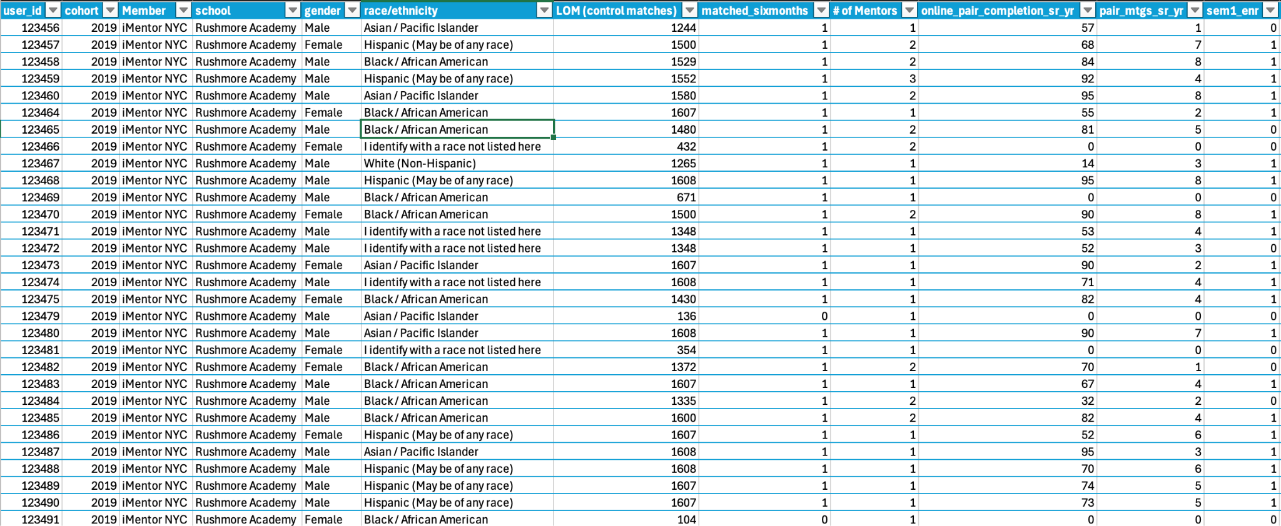
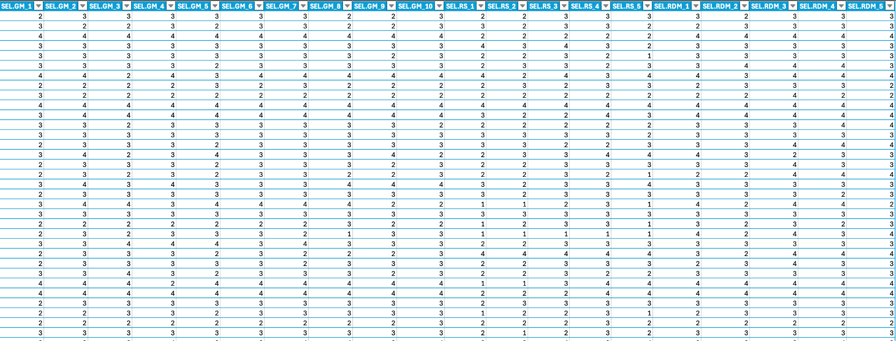

C: College Dataset for External Validation - Snippet
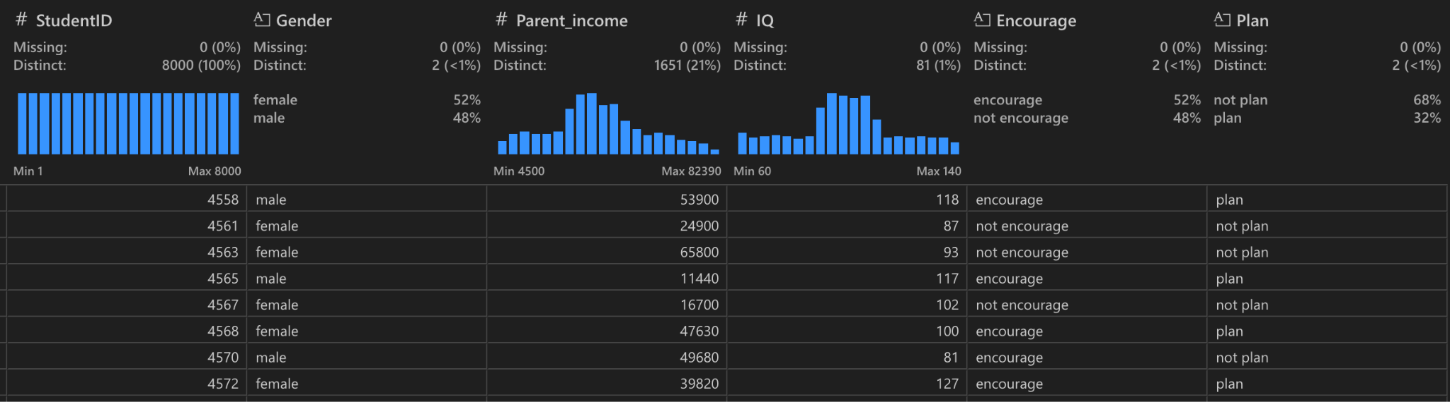
D: Code to Import College Dataset
path = kagglehub.dataset_download("charleyhuang1022/college-plan")
print("Path to dataset files:", path)

# Load the dataset
df_students = pd.read_csv(path + '/college.csv')
print(type(df_students))
df_students.head()

